Test Driven Development (TDD)

Table of Contents

ABAP Unit Testing 2

*Requirement* 2

Global Class 3

Top-Down Approach 3

Addition Operation 3

Subtraction Operation 16

Multiplication Operation 20

Division Operation 23

Bottom-up Approach 27

Addition Operation 27

Subtraction Operation 34

Multiplication Operation 38

Division Operation 43

Local Class 49

Top-Down Approach 49

Addition Operation 49

Subtraction Operation 56

Multiplication Operation 59

Division Operation 62

Test double framework 66

Requirement 66

Interface 66

Class for Interface Implementation 67

Constructor Injection 69

Setter Injection 82

Parameter Injection 86

Backdoor Injection 90

# ABAP Unit Testing

## Requirement

To perform arithmetic operation for Calculator

### Global Class

#### Top-Down Approach

##### Addition Operation

Execute transaction code **SE24** and Enter global class name ‘**ZCL_CALCULATOR’** and click on create button as below screen

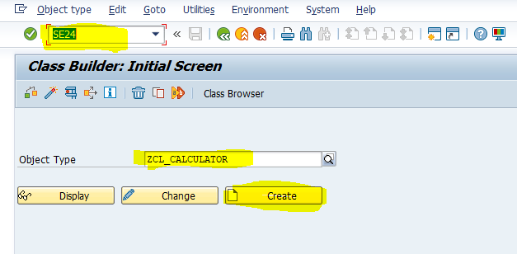

Enter description and click on save button

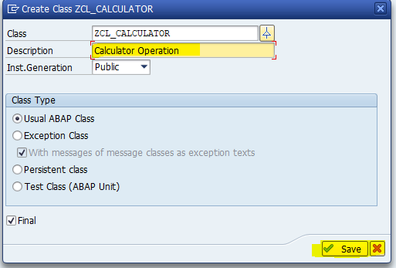

Then class look like as below screen

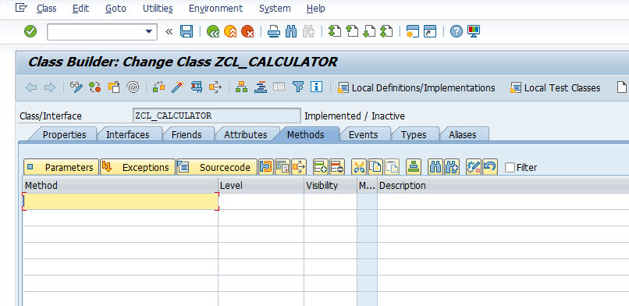

Enter Method ‘ADD’ as below

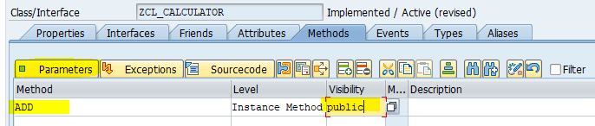

Click on parameter tab to enter importing and exporting parameter to method as below

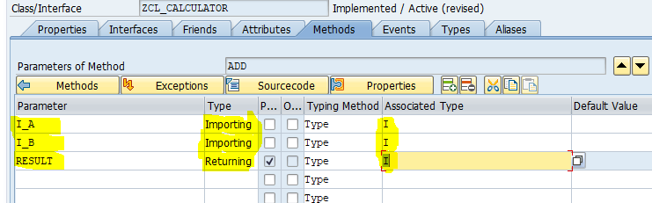

Click on active to activate class

Click on display object list button as below screen

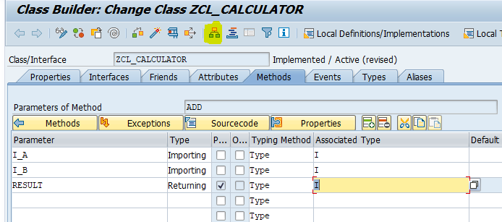

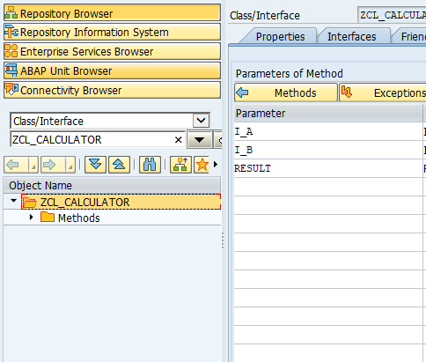

Right click on class ‘**ZCL_CALCULATOR’** and choose path Create->Generate Test class to create test class then below screen will appear

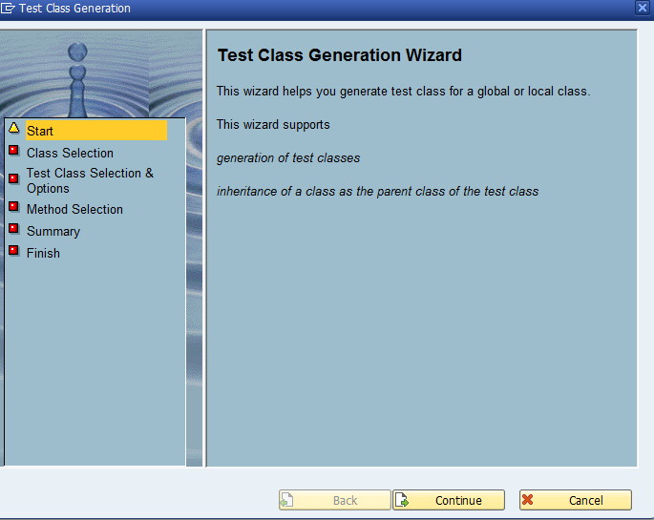

Click on continue button

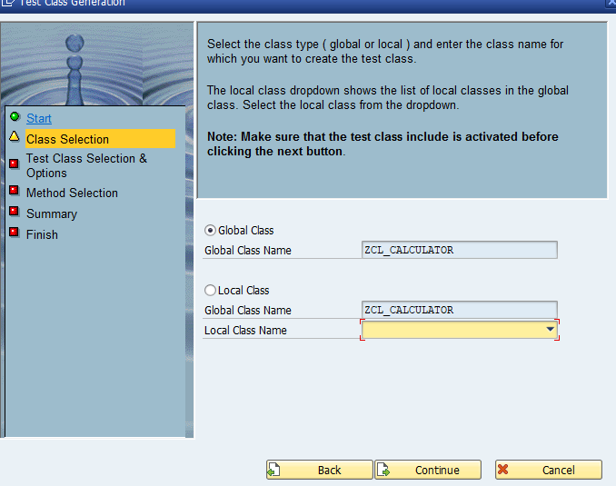

Don’t change anything and click on continue button

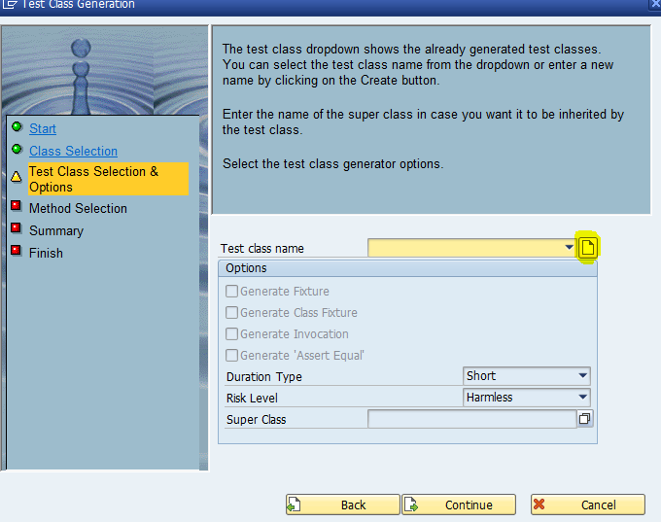

Click on create button to enter local test class name

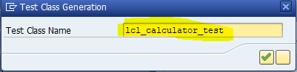

Click on continue button

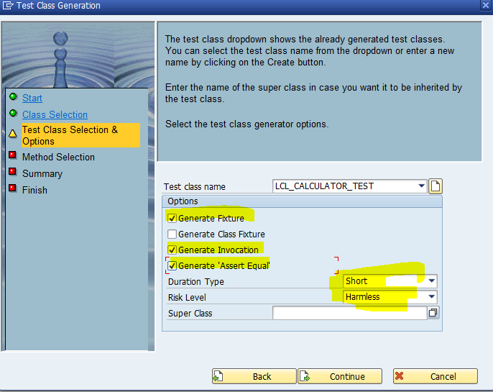

Select Generate Fixture, innovation and ‘**Assert_Equal’** checkbox and choose ‘**short**’ as duration type and ‘**Harmless**’ as Risk level and click on continue button

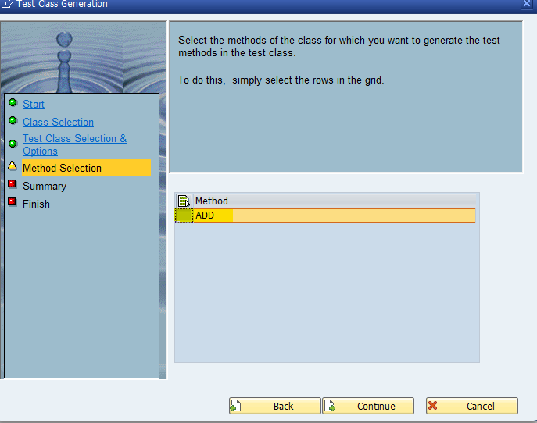

Select method ‘**ADD**’ and click on continue button then next screen will show as below with Global class, Local class, fixture method, duration and risk level and click on continue button

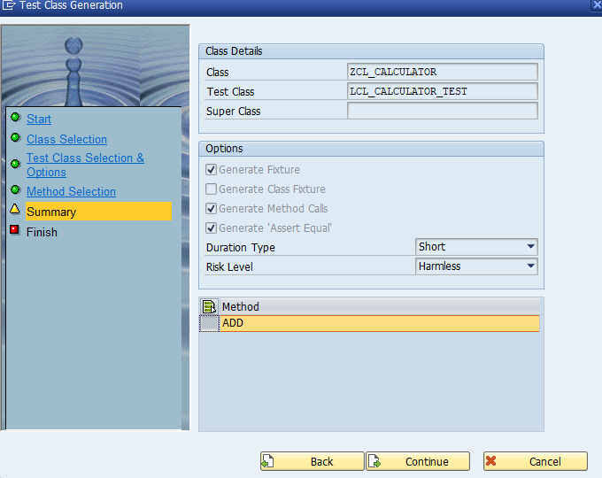

Click on complete button

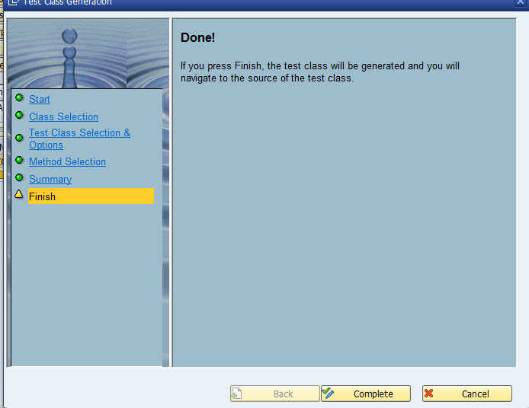

Then local test class will generate with required method as below screen

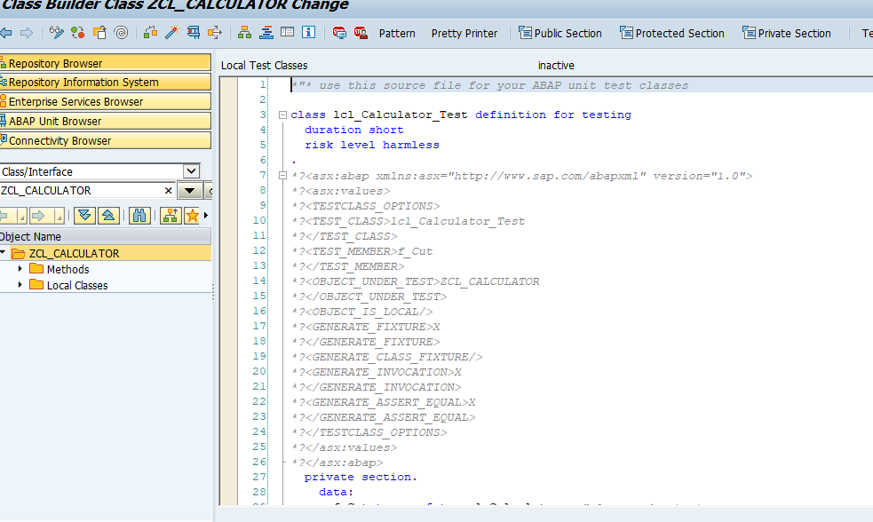

System generated test method ‘**ADD**’ in test class as below screenshot

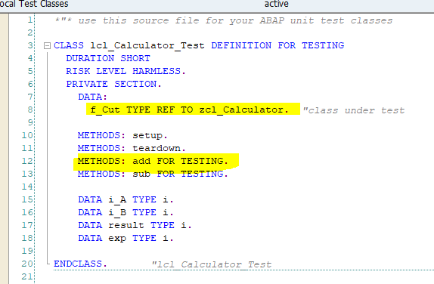

Object “**F_Cut**” is used to access method of product code

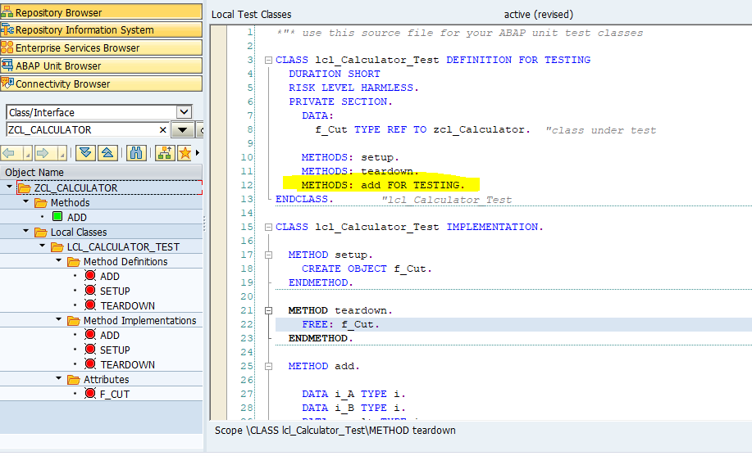

Pass the Given value as

I_A = 5, I_B = 2

Expected Result = 7

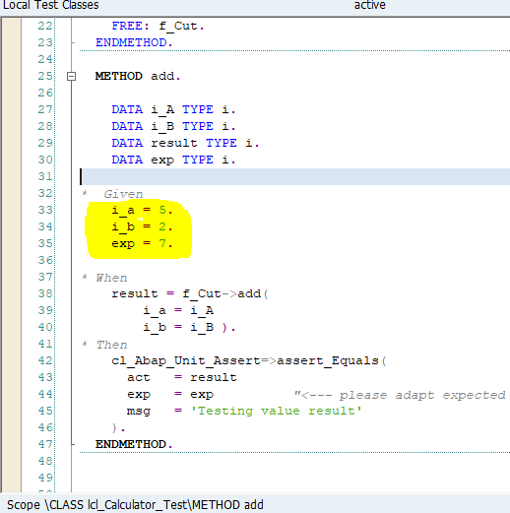

Execute test by shortcut ‘**Ctrl+Shift+F10**’ or Menu path ‘**Local test class->Execute->Unit Tests’**

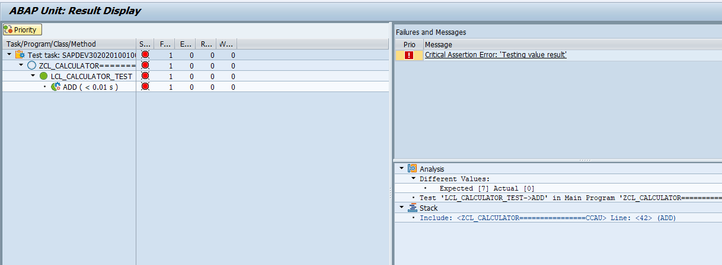

Unit test is fail because no logic inside the product method ‘**ADD**’

Refactor product method code to Pass test case as below

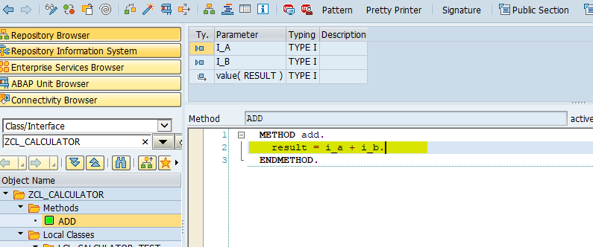

Activate class and run unit test then unit test case will pass

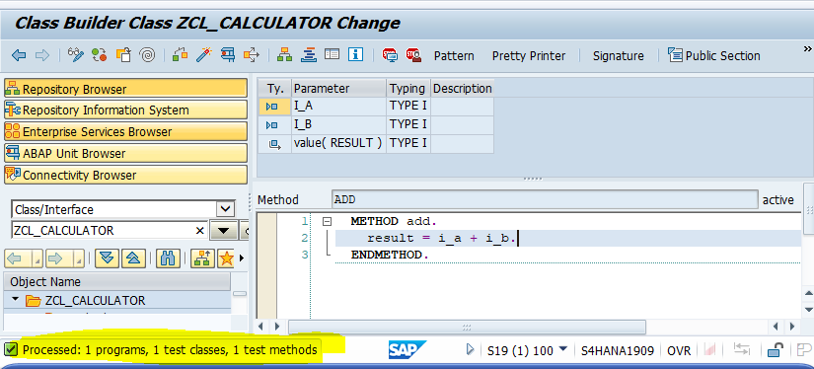

##### Subtraction Operation

Add method ‘**SUB**’ for subtraction in product code class as below

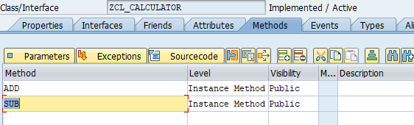

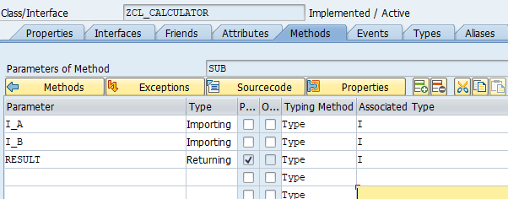

Click on ‘Local test class’ menu button to goes to test class

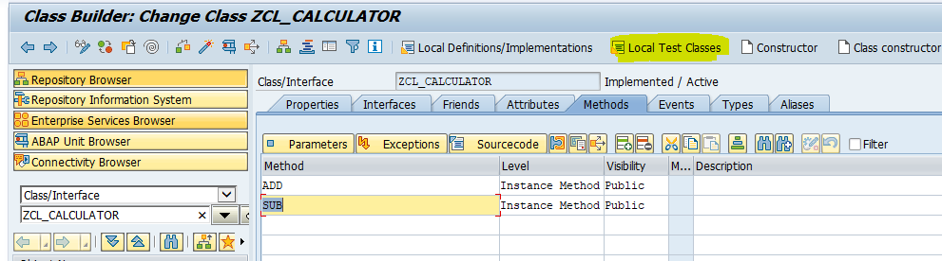

Add “**SUB**” test method in test class definition as below

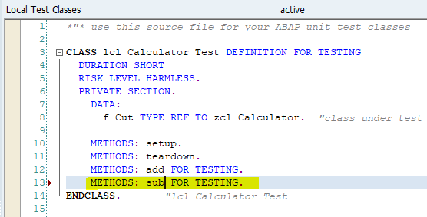

Implement ‘SUB’ method as below and pass Given value

I_A = 5, I_B = 2

Expected Result = 3

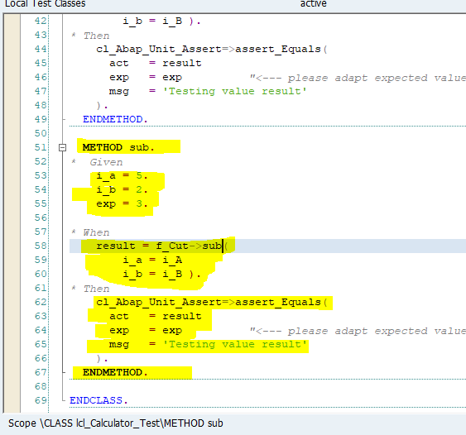

Execute test by shortcut ‘**Ctrl+Shift+F10’** or Menu path ‘**Local test class->Execute->Unit Tests’**

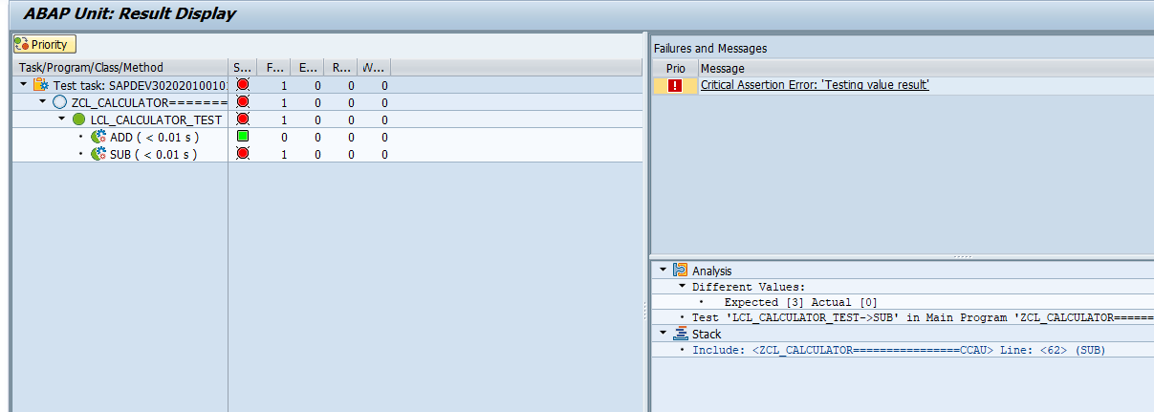

Test method ‘**SUB**’ fail because no product code written inside product method ‘**SUB**’

Refactor product method ‘**SUB**’ code to pass test case as below

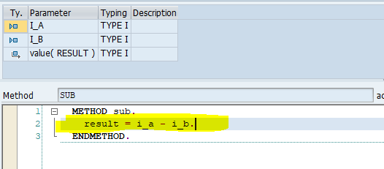

Execute unit test once again

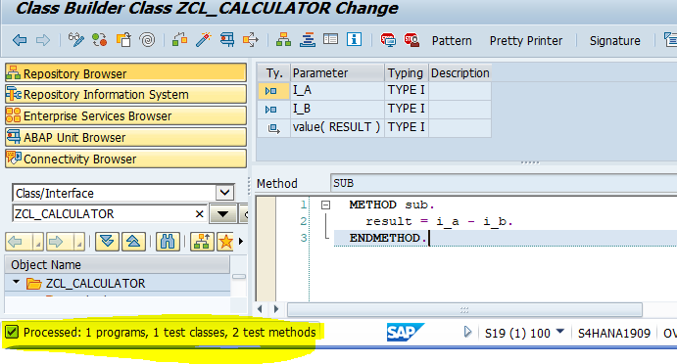

Now two test methods passed

##### Multiplication Operation

Add method ‘**MULT**’ in product code for multiplication operation as below

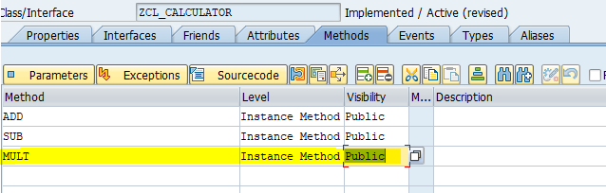

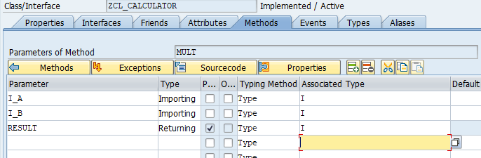

And activate class

Go to local test class and add ‘**MULT**’ test method in test class definition as below

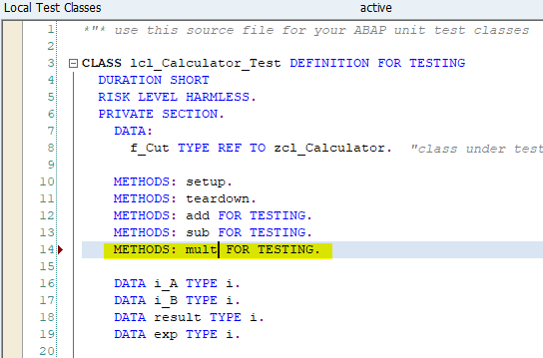

Implement test method ‘**MULT**’ as below

pass Given value

I_A = 5, I_B = 2

Expected Result = 10

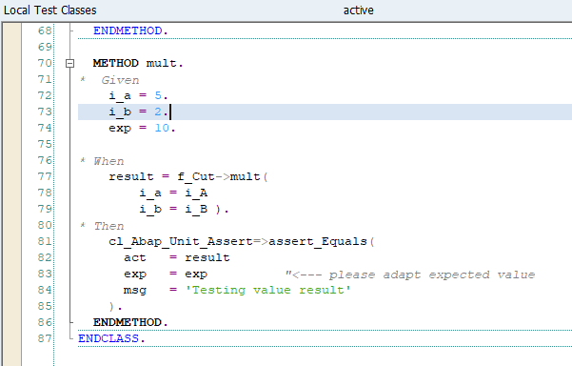

Execute test by shortcut ‘Ctrl+Shift+F10’ or Menu path ‘Local test class->Execute->Unit Tests’

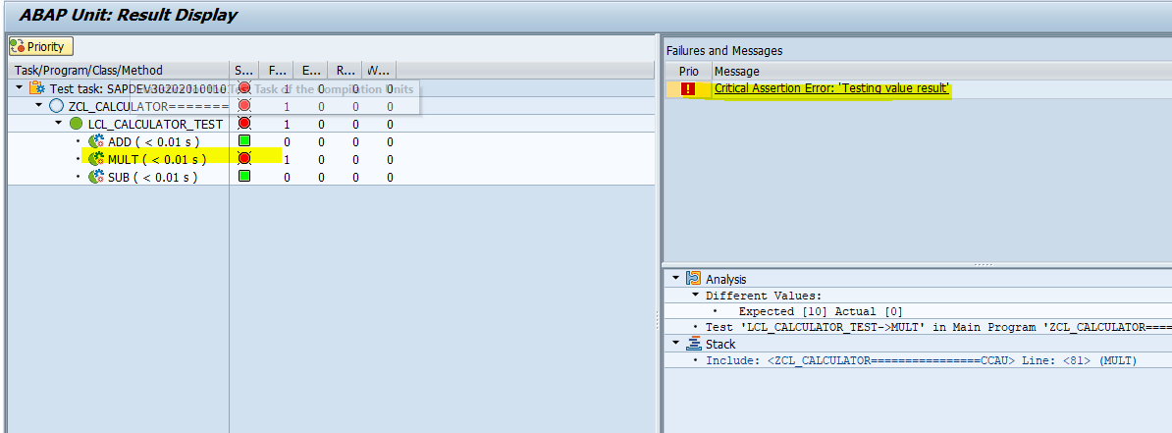

Test method **‘MULT’** is fail because no product code exist. Refactor product code method to pass test method **‘MULT’** as below

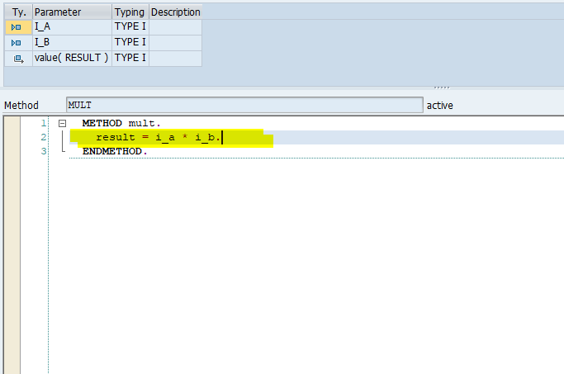

Execute unit test once again

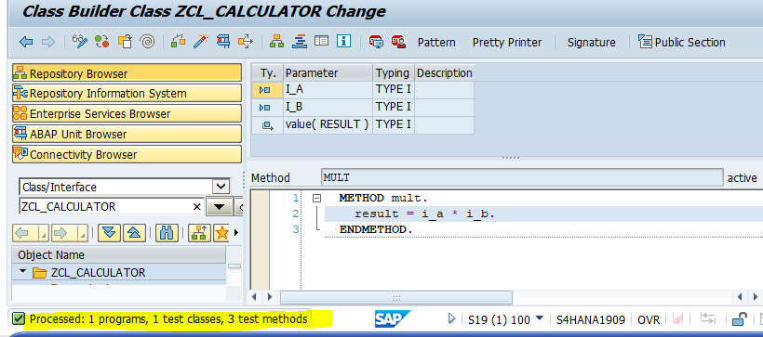

Now test method ‘**MULT’** is passed

##### Division Operation

Add method **‘DIV’** in product code for multiplication operation as below

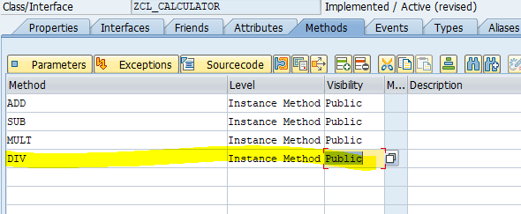

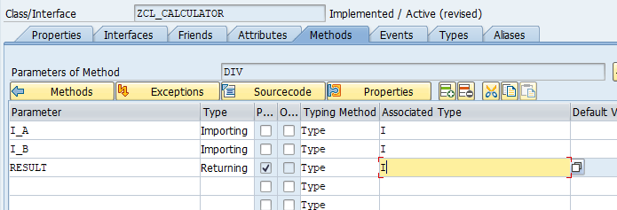

And activate class

Go to local test class and add ‘DIV’ test method in test class definition as below

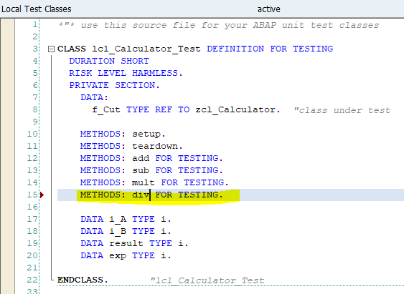

Implement test method ‘**DIV**’ as below

pass Given value

I_A = 6, I_B = 2

Expected Result = 3

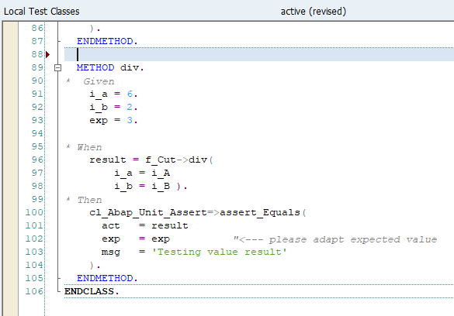

Execute test by shortcut ‘**Ctrl+Shift+F10’** or Menu path ‘**Local test class->Execute->Unit Tests’**

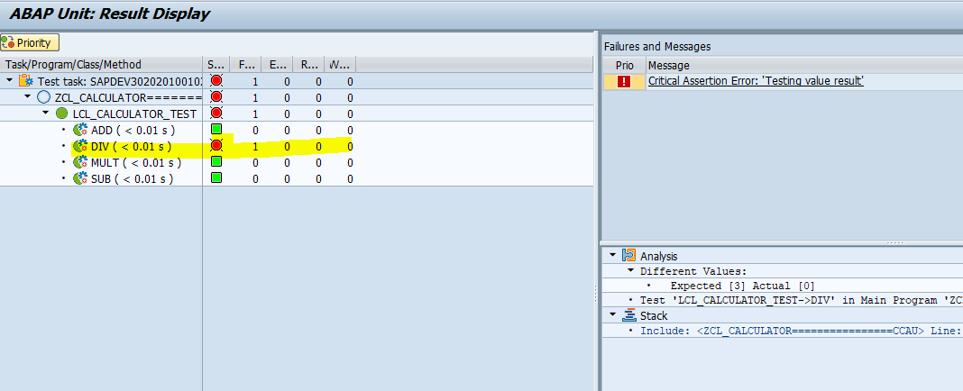

Test method ‘**DIV’** is fail because no product code exist. Refactor product code method to pass test method ‘**DIV**’ as below

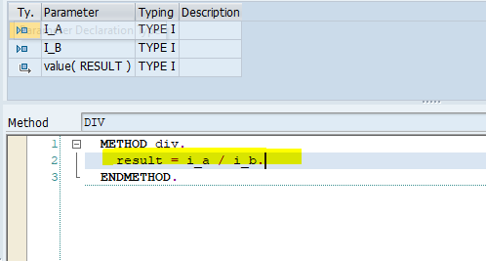

Execute unit test once again

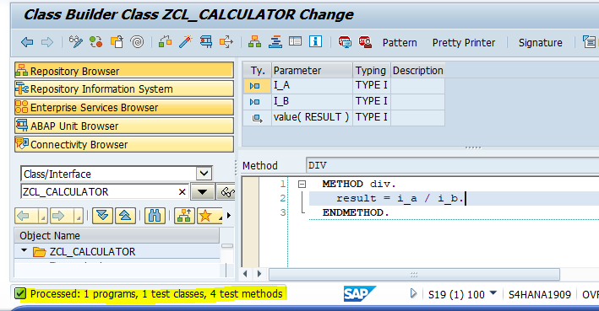

Now test method ‘**DIV**’ is passed

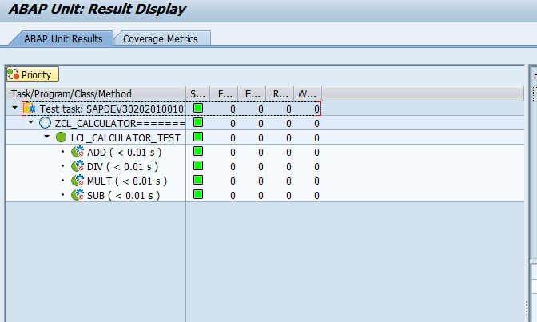

#### Bottom-up Approach

##### Addition Operation

Execute transaction code SE24 and Enter class name ‘**ZCL_CALCULATOR1**’ and click on create button to create global class

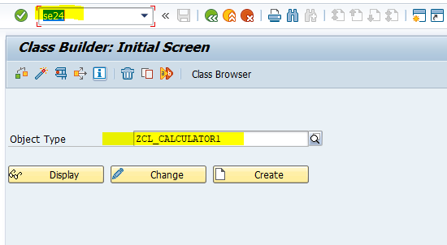

Enter class description and click on save button

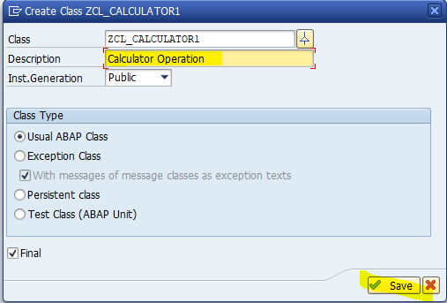

Then class look like as below

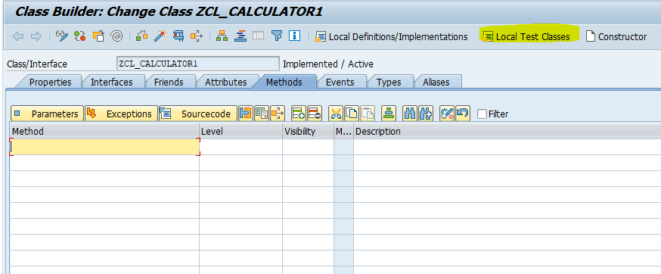

Click on Local Test Classes Menu button to write local test class

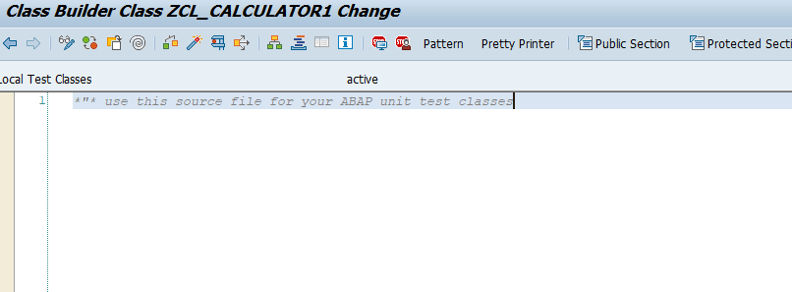

Write Local test class definition and implementation with fixture method as below

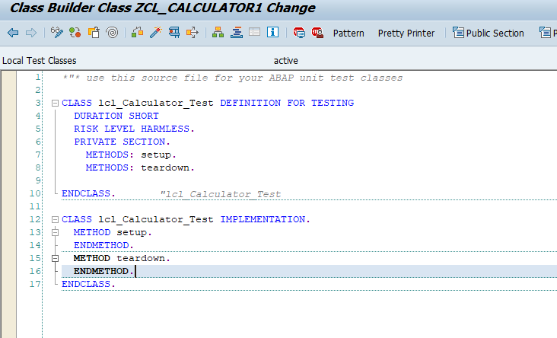

Add Test method ‘**ADD**’ in test class definition, implementation and pass Given data

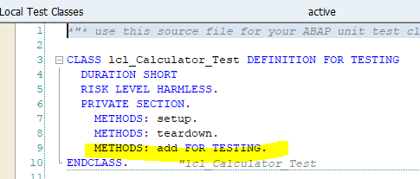

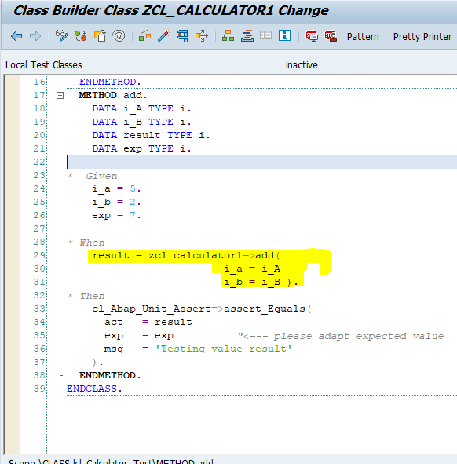

Double click on **ADD** method to create this method in product class

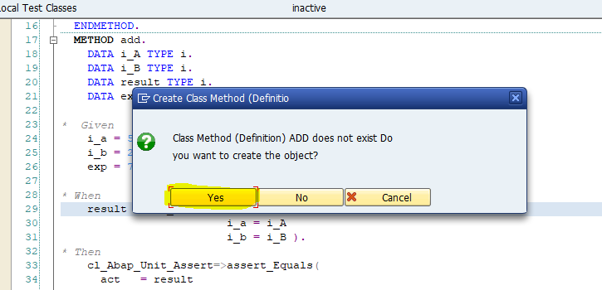

Click on Yes button

Enter Method description, Visibility as public and method as static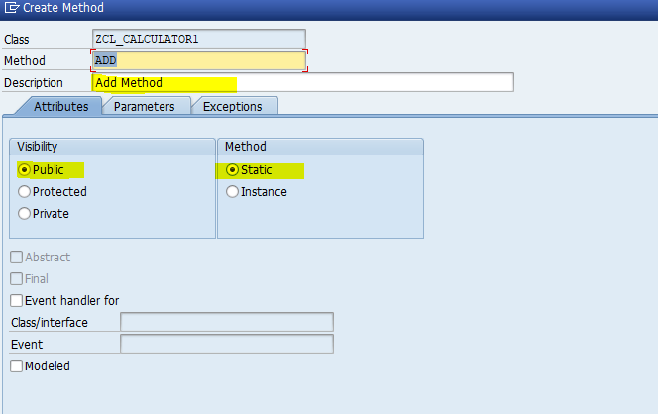

Enter parameter in parameter tab

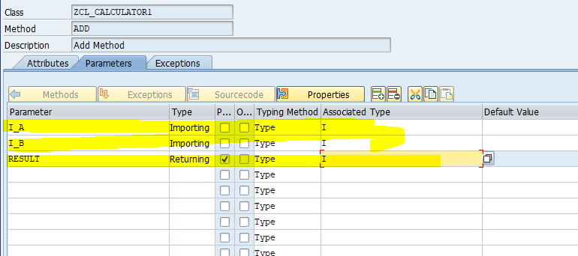

And click on create button

Now method “**ADD**” is added in product class

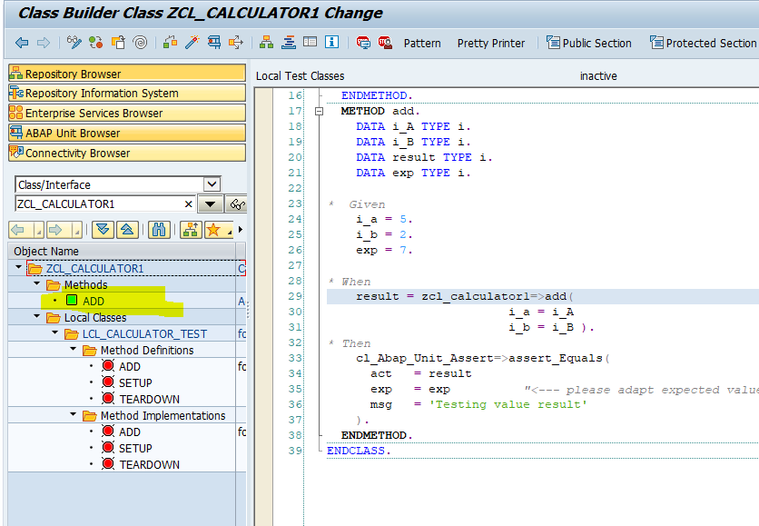

Activate class and Execute test by shortcut ‘**Ctrl+Shift+F10’** or Menu path ‘**Local test class->Execute->Unit Tests’**

Unit testing fail for **ADD** method because no product code exist in product method in product class

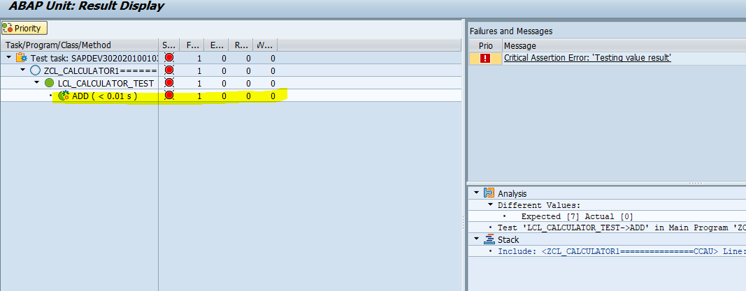

Refactor product method code to pass test case as below

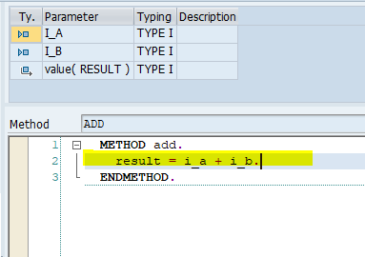

Execute unit test once again

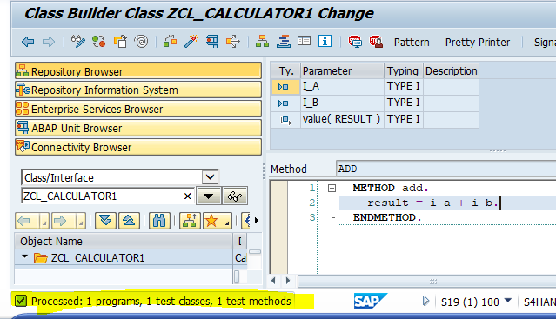

Now test case is passed

##### Subtraction Operation

Add Test method **‘SUB’** in test class definition, implementation and pass Given data

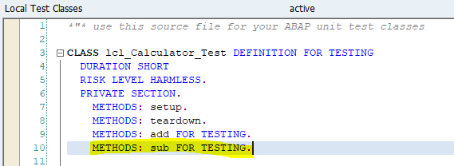

Add input and export into test class definition as below

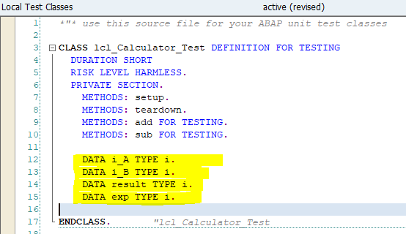

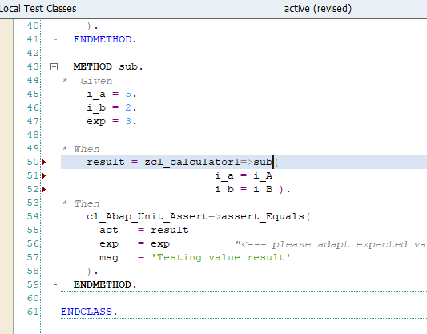

Double click on **SUB** method to create this method in product class

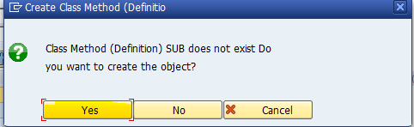

Click on Yes button

Enter Method description, Visibility as public and method as static 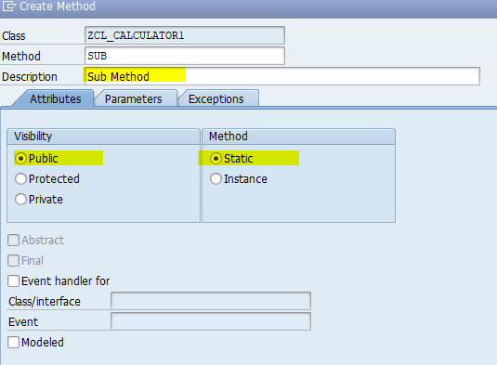

Enter parameter in parameter tab

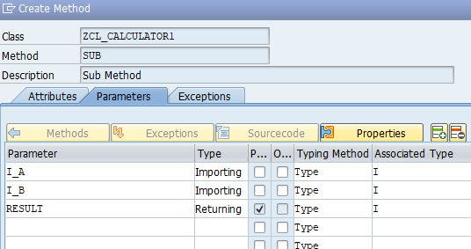

And click on create button

Now **SUB** method is added in product class

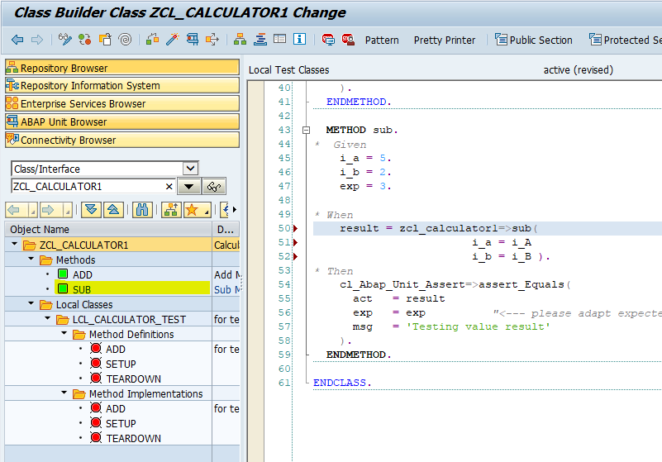

Activate class and Execute test by shortcut ‘**Ctrl+Shift+F10’** or Menu path ‘**Local test class->Execute->Unit Tests’**

Unit testing fail for **SUB** method because no product code exist in product method in product class

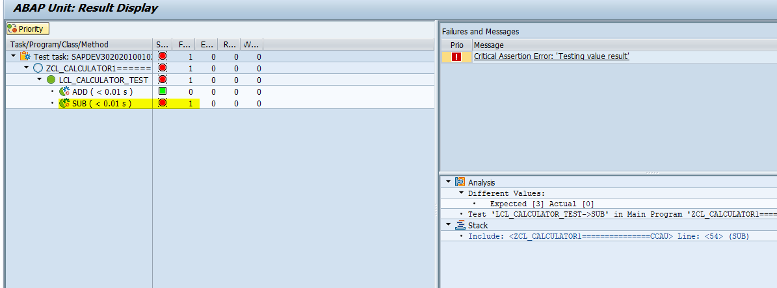

Refactor product method code to pass test case as below

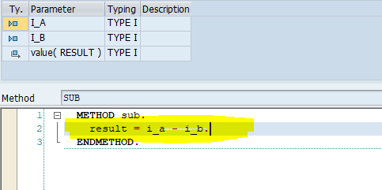

Execute unit test once again

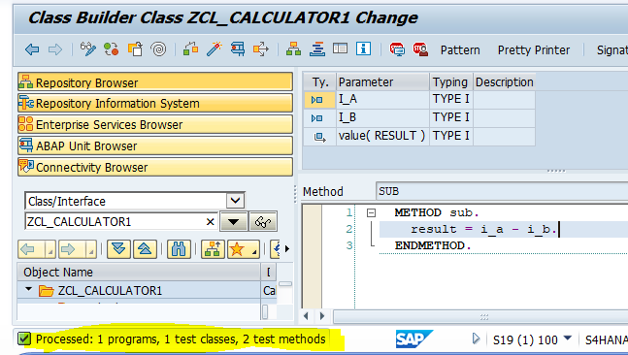

Now test case is passed

##### Multiplication Operation

Add Test method ‘**MULT**’ in test class definition, implementation and pass Given data

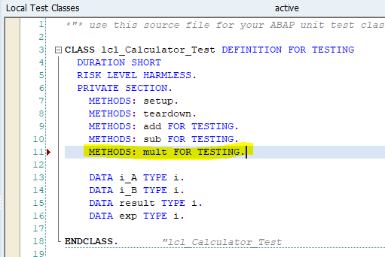

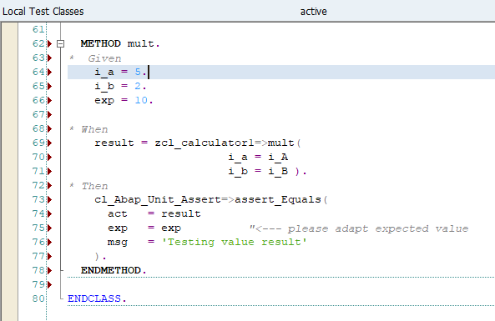

Double click on **MULT** method to create this method in product class

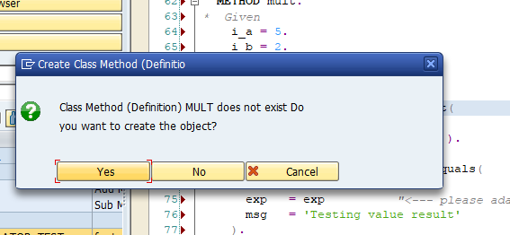

Click on Yes button

Enter Method description, Visibility as public and method as static 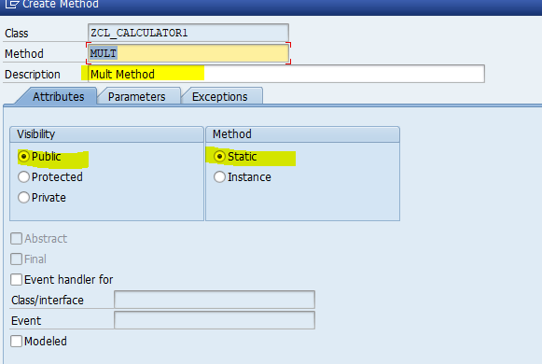

Enter parameter in parameter tab

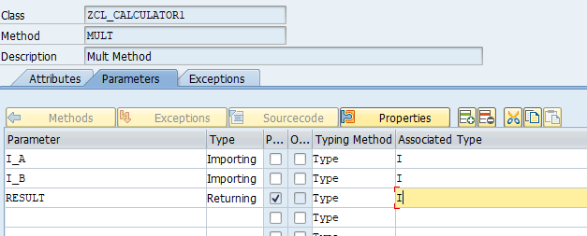

And click on create button

Now MULT method is added in product class

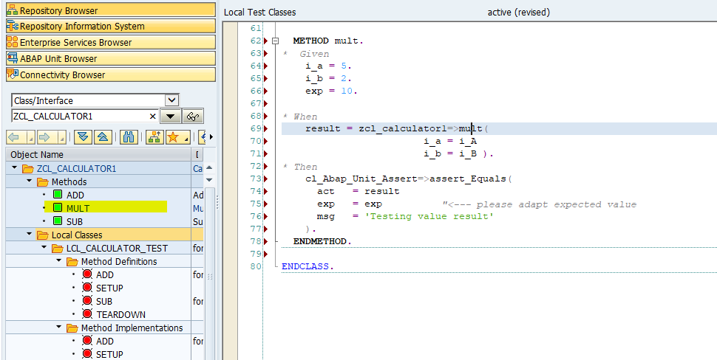

Activate class and Execute test by shortcut ‘**Ctrl+Shift+F10’** or Menu path ‘**Local test class->Execute->Unit Tests**’

Unit testing fail for **MULT** method because no product code exist in product method in product class

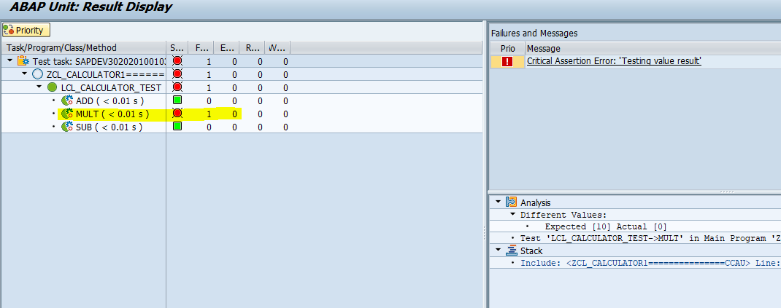

Refactor product method code to pass test case as below

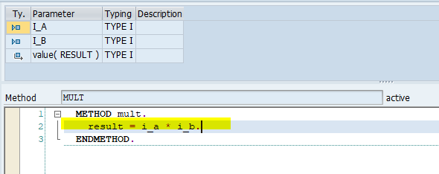

Execute unit test once again

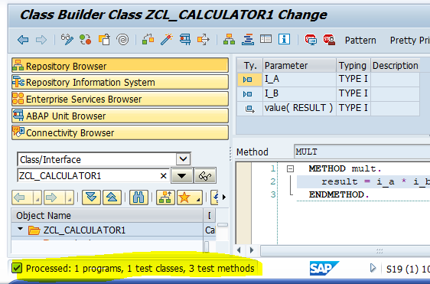

Now test case is passed

##### Division Operation

Add Test method ‘DIV’ in test class definition, implementation and pass Given data

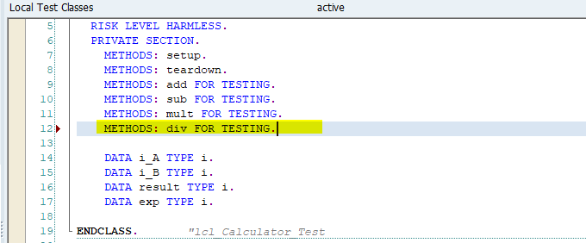

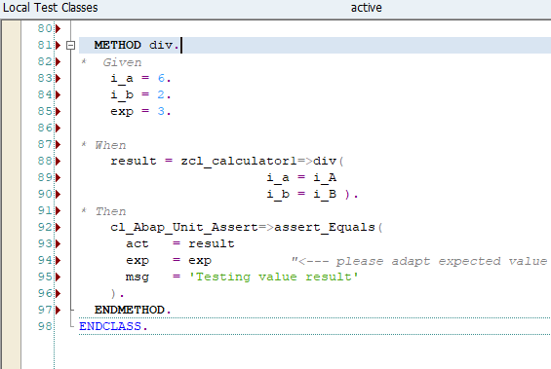

Double click on **DIV** method to create this method in product class

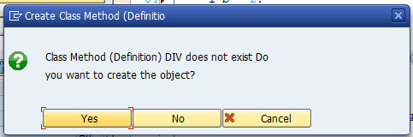

Click on Yes button

Enter Method description, Visibility as public and method as static 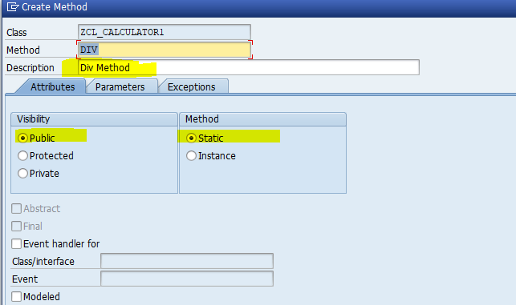

Enter parameter in parameter tab

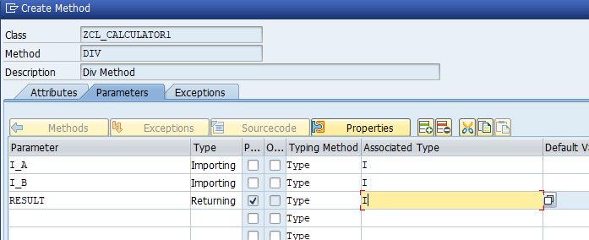

And click on create button

Now **DIV** method is added in product class

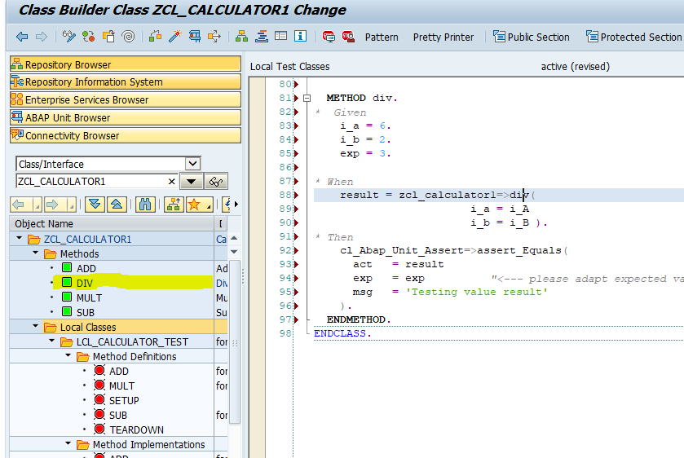

Activate class and Execute test by shortcut ‘**Ctrl+Shift+F10’** or Menu path ‘**Local test class->Execute->Unit Tests**’

Unit testing fail for **DIV** method because no product code exist in product method in product class

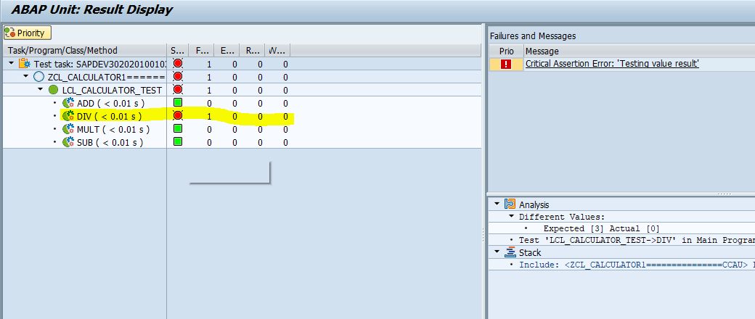

Refactor product method code to pass test case as below

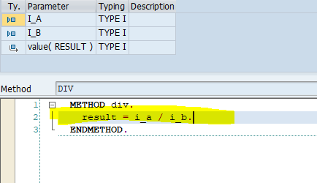

Execute unit test once again

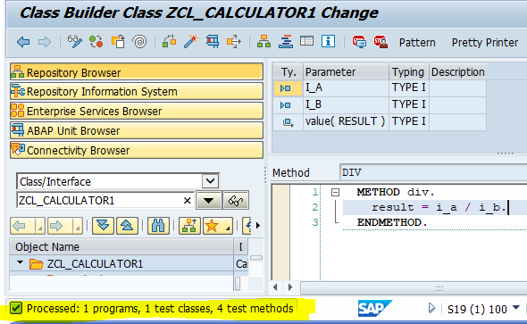

Now test case is passed

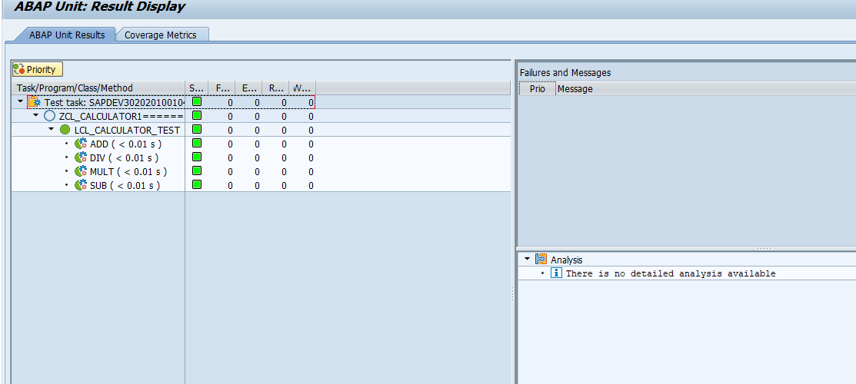

### Local Class

#### Top-Down Approach

##### Addition Operation

Execute transaction code SE38 and Enter report name ‘**ZCALCULATOR**’ and click on create button

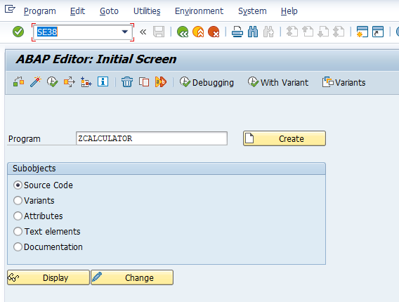

Enter report description, type and click in save button

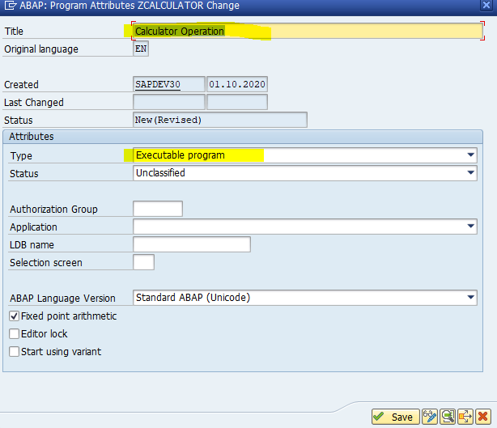

In report editor write local product class definition and implementation as below

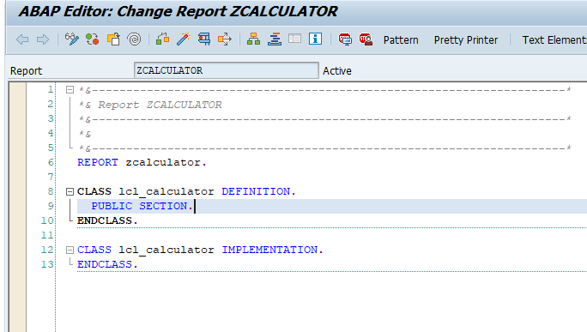

Add method ‘**ADD**’ in product class definition with parameter and implementation as below

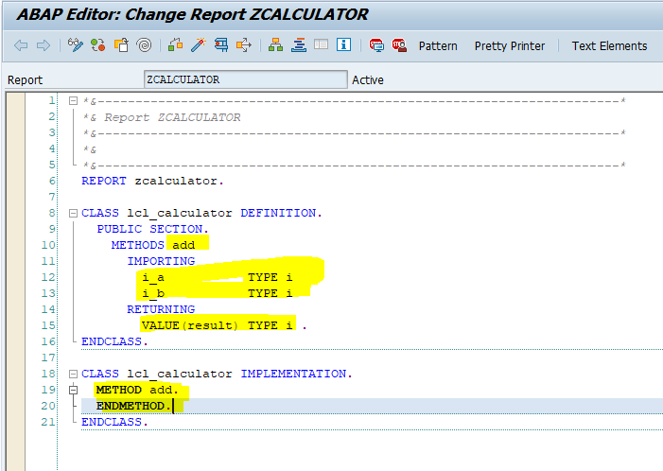

Write down local test class below the product class as below

Declare Object ‘**f_cut**’ with reference to product class and it is used to call method product into test class for writing test cases.

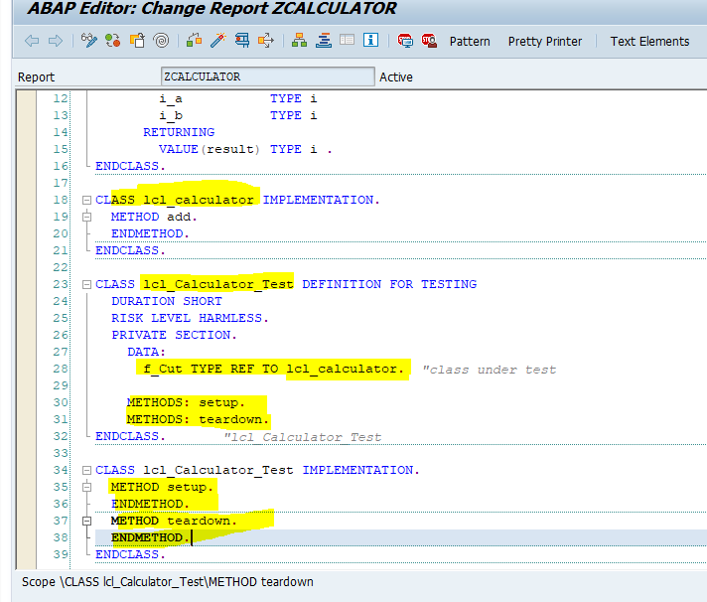

Create object ‘**f_cut’** in setup method and free memory assigned to object in teardown method as below

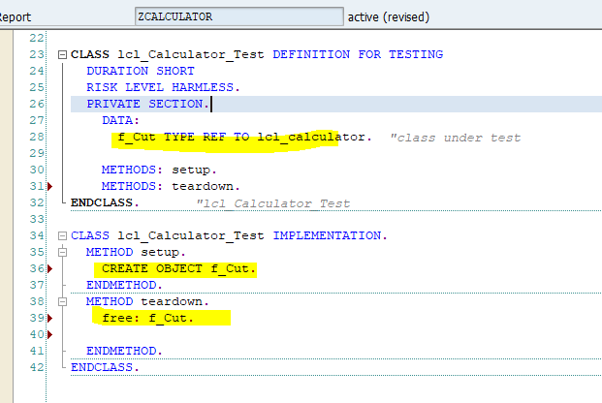

Add test method ‘**ADD**’ in local test class definition as below

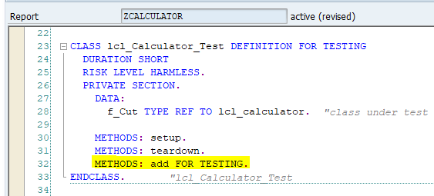

Implement test method with given data as below.

Calling Product method ‘**ADD**’ by reference object ‘**f_cut**’ in test method

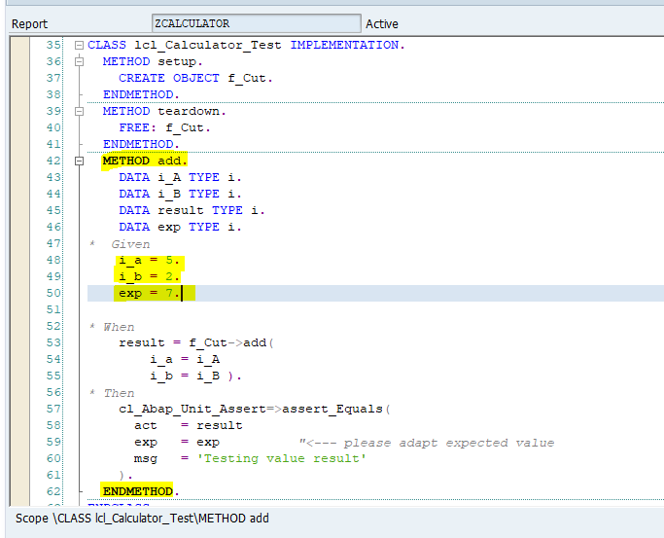

Activate report and use shortcut ‘**Ctrl+Shift+F10’** or use menu path ‘**Program->Execute->Unit Tests’** to trigger unit test cases

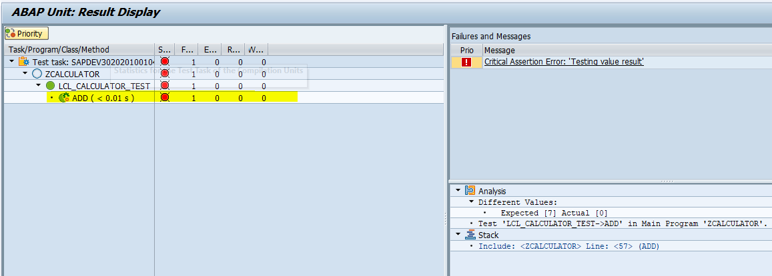

Test case is fail because no product code exist inside product method. Refactor product method to pass test case

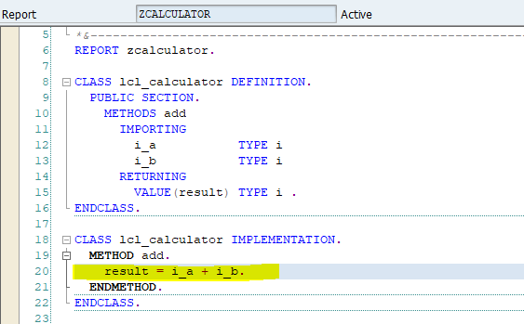

Now test case is passed

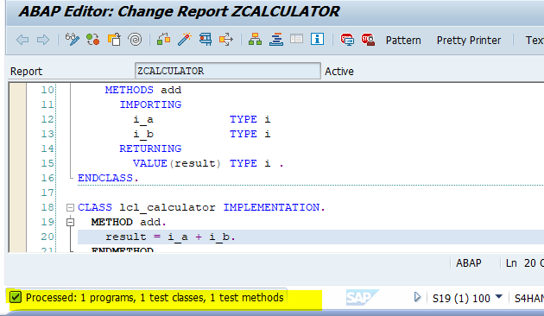

##### Subtraction Operation

Add method ‘**SUB**’ in product class definition with parameters and implementation as below

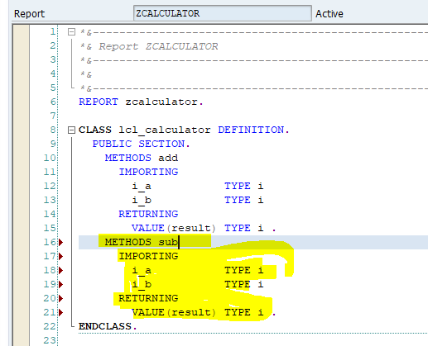

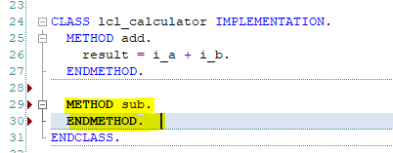

Add test method ‘**SUB**’ in local test class definition as below

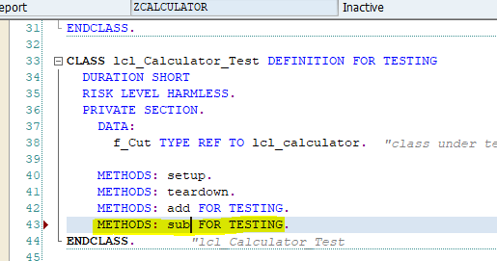

Implement test method with given data as below.

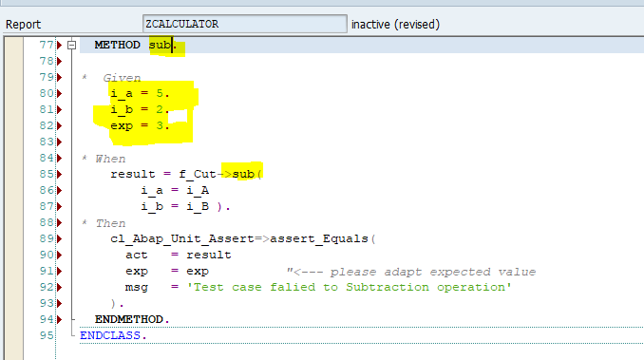

Activate report and use shortcut ‘**Ctrl+Shift+F10’** or use menu path ‘**Program->Execute->Unit Tests’** to trigger unit test cases

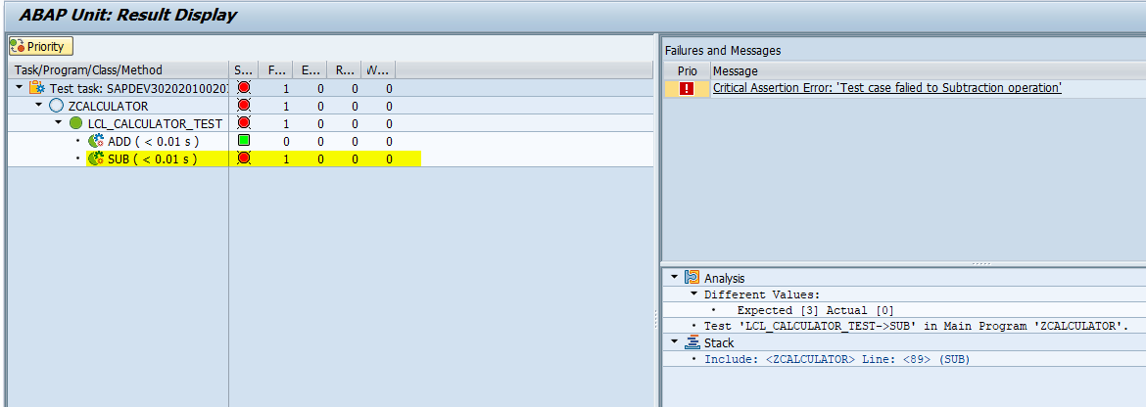

Test case is fail because no product code exist inside product method. Refactor Product method code to pass test case as below

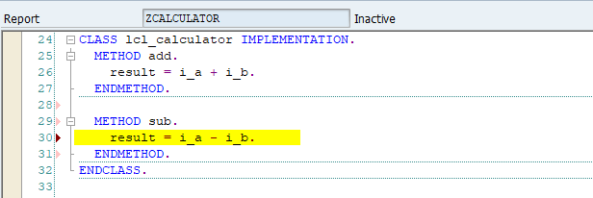

Now test case is passed

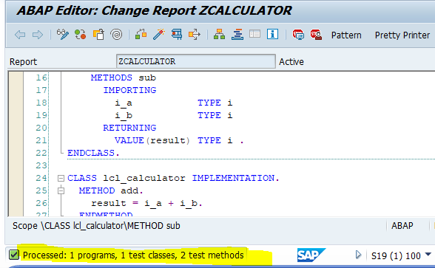

##### Multiplication Operation

Add method ‘**MULT**’ in product class definition with parameter and implementation as below

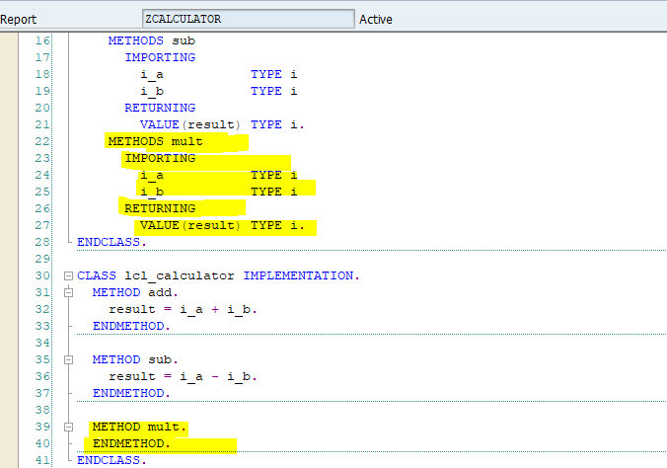

Add test method ‘**MULT**’ in local test class definition as below

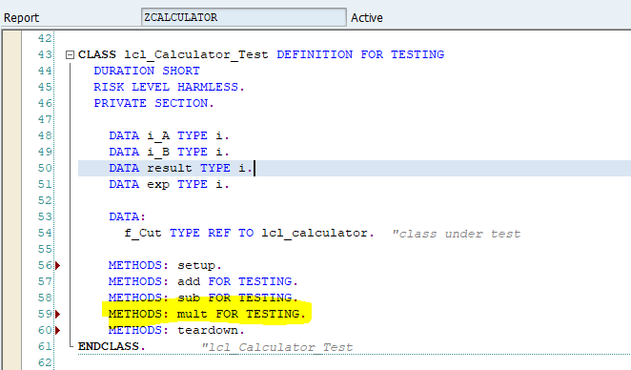

Implement test method with given data as below.

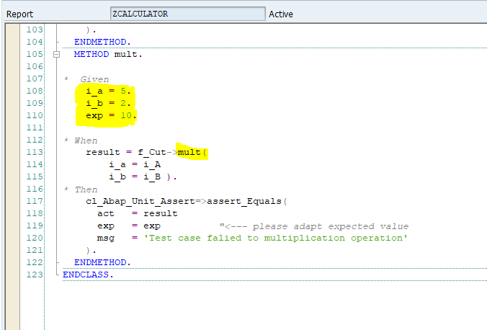

Activate report and use shortcut ‘Ctrl+Shift+F10’ or use menu path ‘Program->Execute->Unit Tests’ to trigger unit test cases

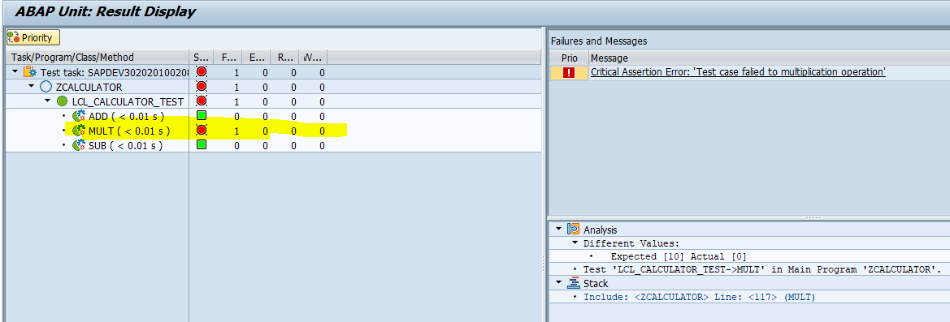

Test case is fail because no product exist inside product method. Refactor Product method to pass test case as below

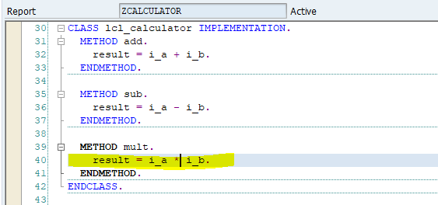

Now test case passed

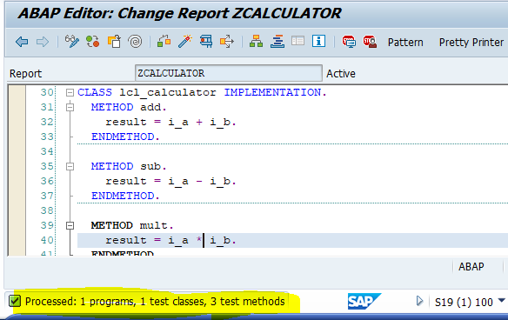

##### Division Operation

Add method ‘**DIV**’ in product class definition with parameter and implementation as below

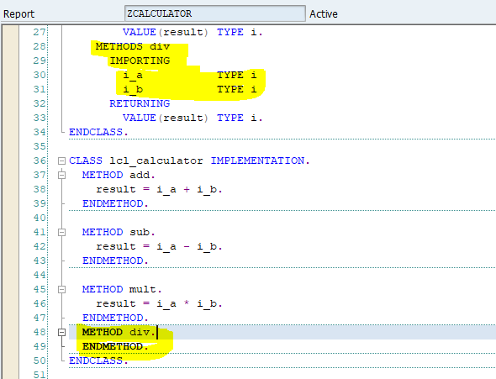

Add test method ‘**DIV**’ in local test class definition as below

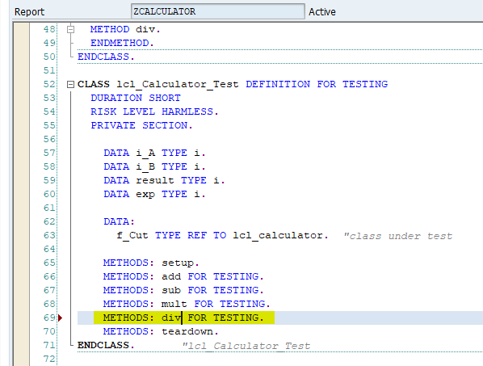

Implement test method with given data as below.

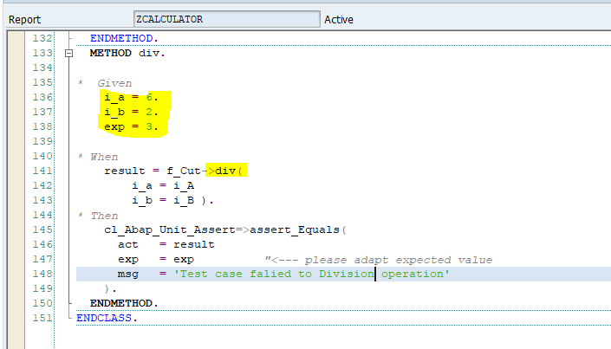

Activate report and use shortcut ‘**Ctrl+Shift+F10’** or use menu path ‘**Program->Execute->Unit Tests’** to trigger unit test cases

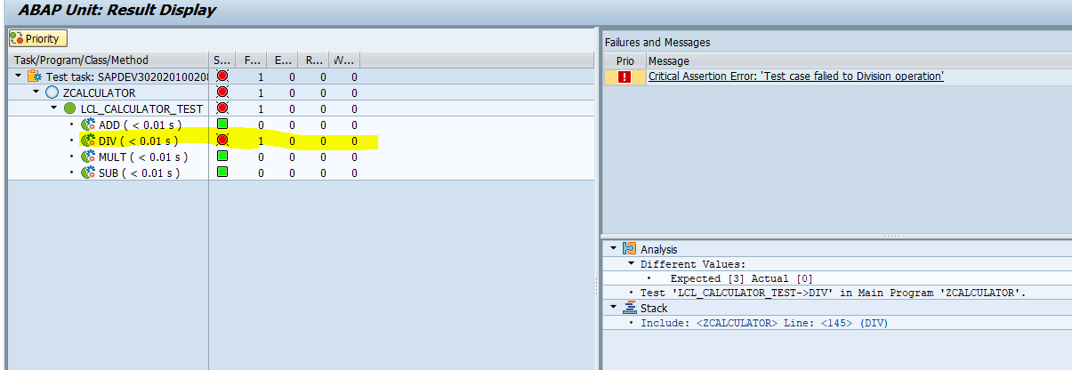

Test case is fail because no product code exist inside product method. Refactor Product method to pass test case as below

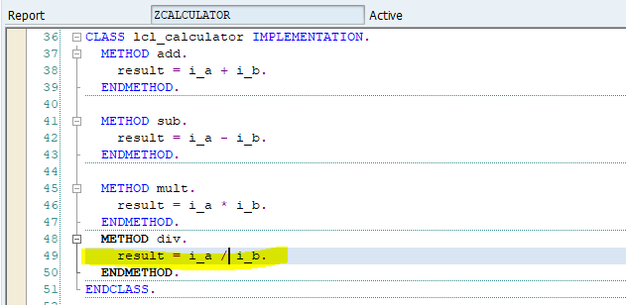

Now test case passed

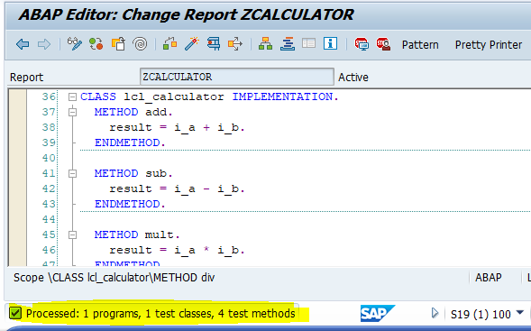

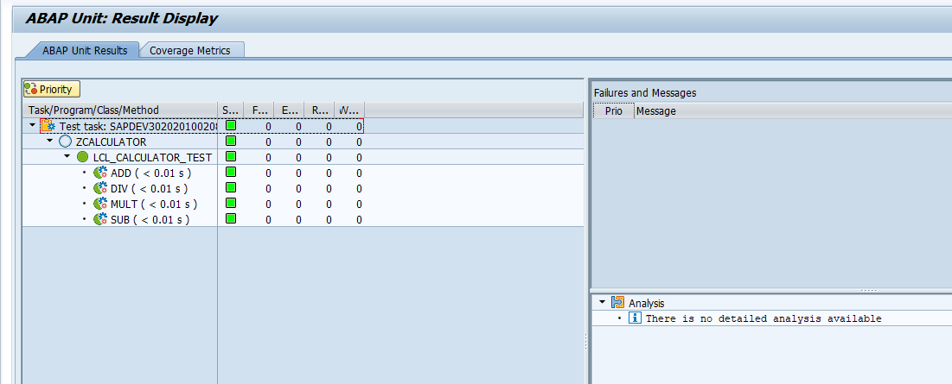

# Test double framework

## Requirement

To get Material text against material no and language

### Top-Down Approach

#### Interface

Execute transaction code **SE24** and Enter interface name ‘**ZIF_MATERIAL_TEXT**’ and click on create button

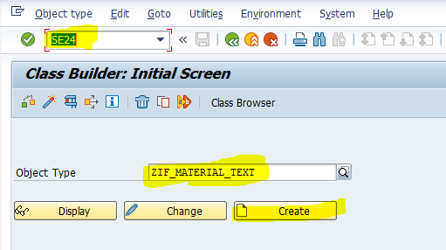

Enter description and click on save button

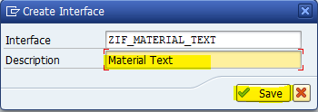

Then Interface screen look like as below

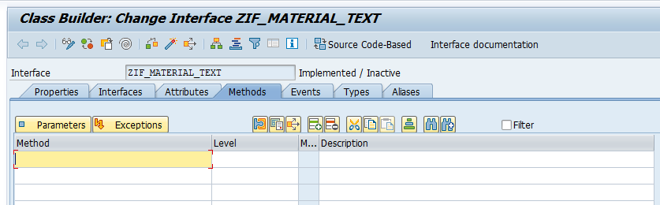

Enter method name ‘**GET_MATERIAL_TEXT**’

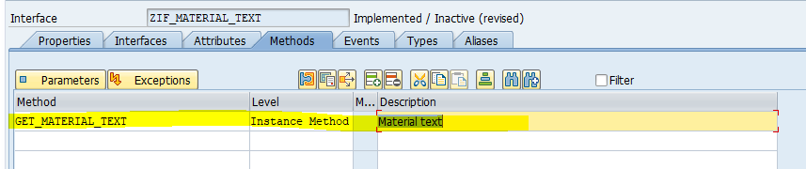

Select method and click on parameter tab

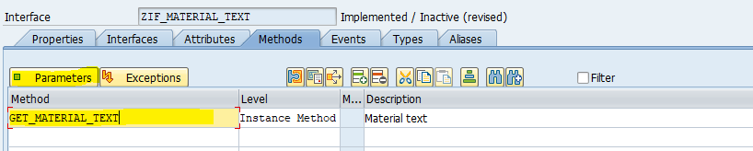

Enter importing and exporting parameter as below

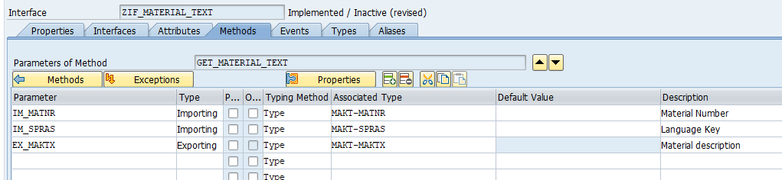

Activate Interface

#### Class for Interface Implementation

Create class ‘**ZCL_MATERIAL_TEXT**’ to implement interface ‘**ZIF_MATERIAL_TEXT**’

Execute transaction code ‘**SE24**’ and Enter Class name ‘**ZCL_MATERIAL_TEXT**’ and click on create button

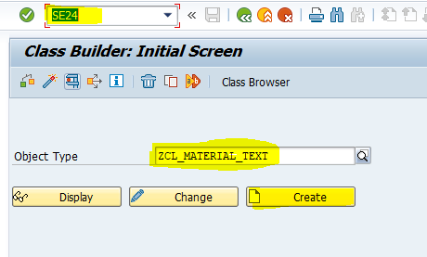

Enter Description and click on save button

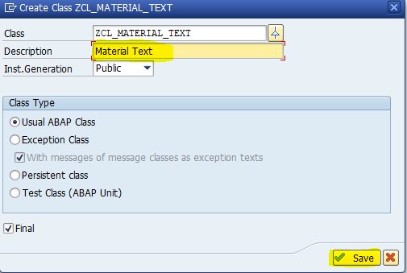

Then class look like as below

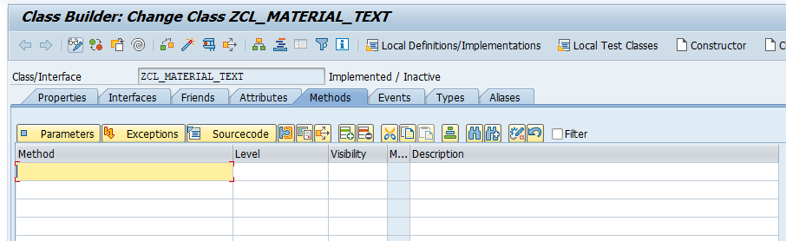

Click in Interface tab and enter interface name ‘**ZIF_MATERIAL_TEXT**’

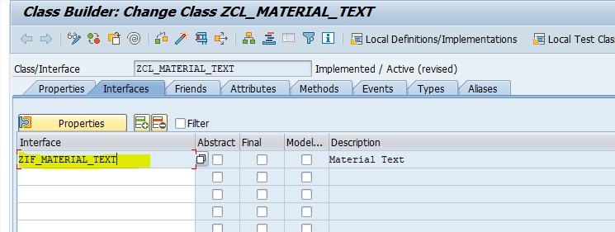

Interface method will display in method tab as below

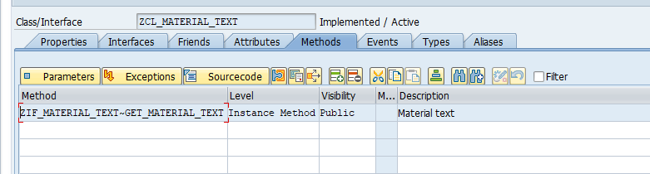

Double click on method name and add business logic inside method as below

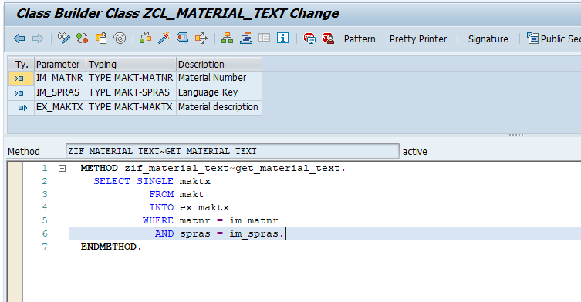

Activate class

##### Constructor Injection

Configure test double framework using constructor injection

Execute transaction code ‘**SE24**’ and Enter class name ‘**ZCL_MATERIAL_TEXT_CONSTR_CUT**’ and click on Create button

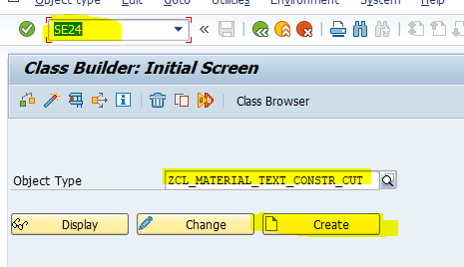

Enter description and click on save button

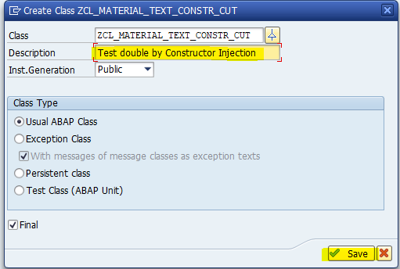

Click on constructor menu button to add constructor method in class

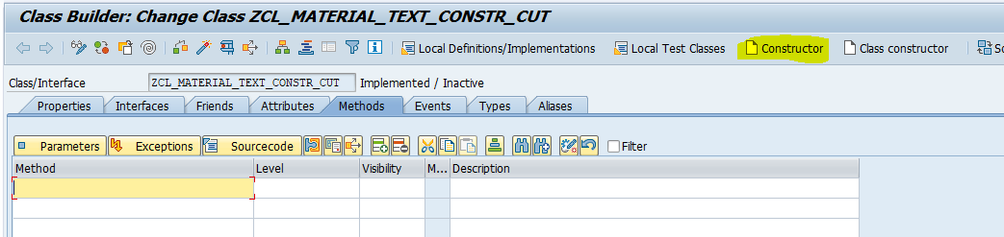

Then Constructor method is added in method

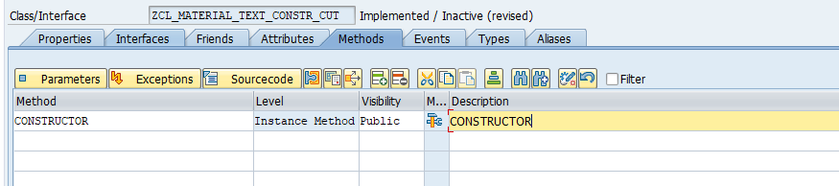

Click on parameter tab and Add parameter ‘**GD_DOA**’ with reference to Interface ‘**ZIF_MATERIAL_TEXT**’ and make it as optional

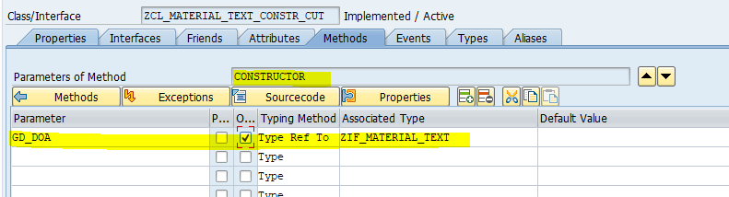

Add method ‘**GET_MATERIAL_TEXT’** in method tab

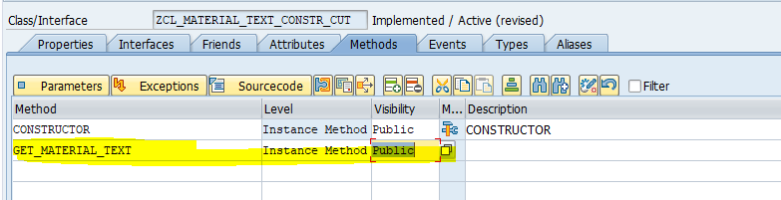

Click on parameter tab to add parameter in method

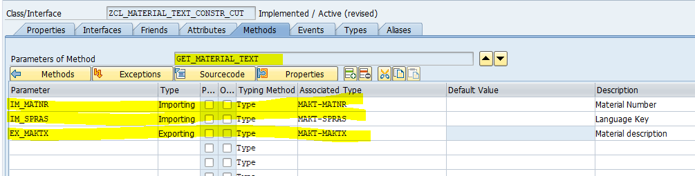

Activate class

Click on display object list button

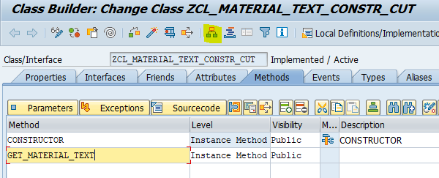

Right click on class name and select path ‘**Create->Generate test class**’ then test class wizard will come as below

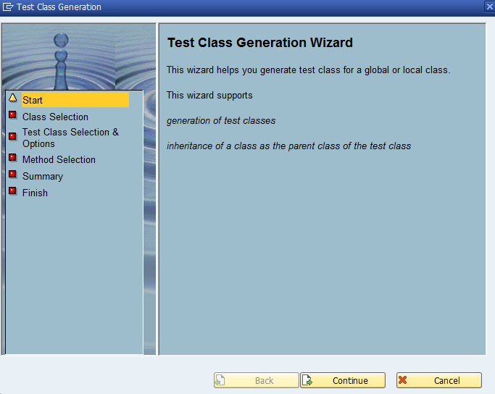

Click on continue button

Don’t change anything and click on continue button

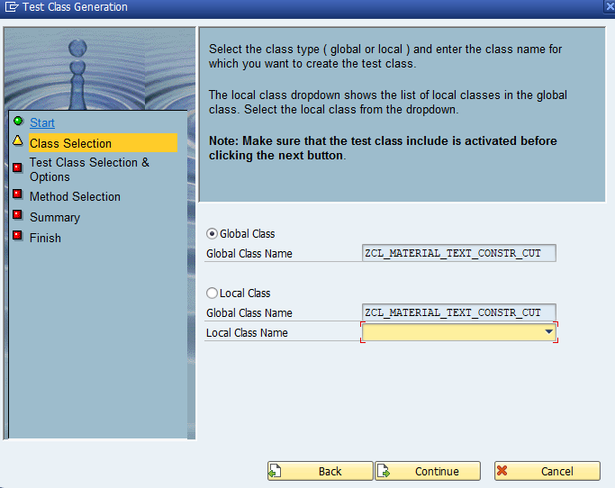

Click on create button

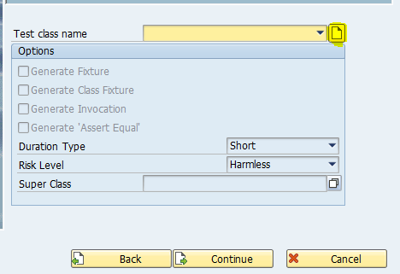

Enter test class name ‘**LCL_MATERIAL_TEXT_TEST**’ and click on ok button

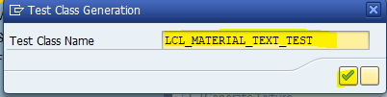

Select checkbox **Generate fixture, generate Invocation , Generate ‘Assert Equal’** duration as ‘**Short**’ and risk level as ‘**harmless**’ as below and click on continue button

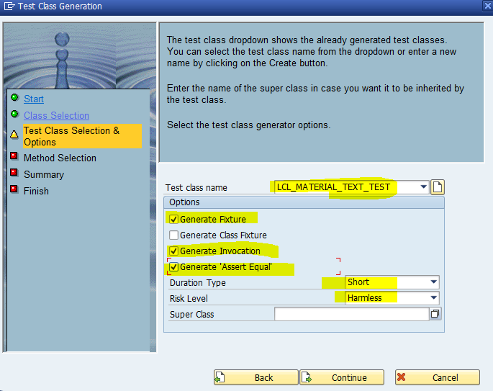

Select method for which we are trying to write unit test cases as below and click on continue button

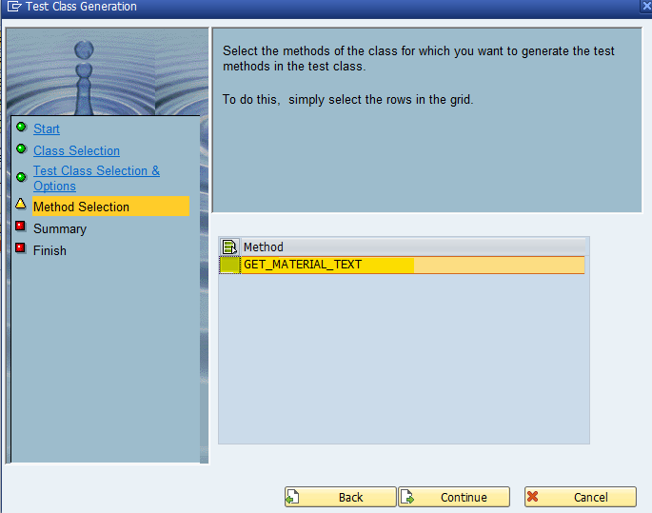

Next screen will display overview screen and click on continue button

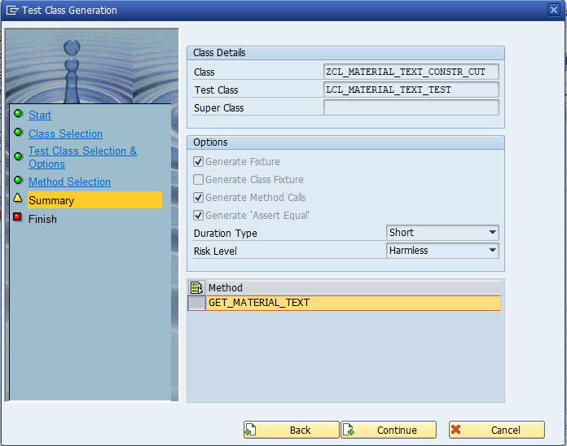

Click on complete button

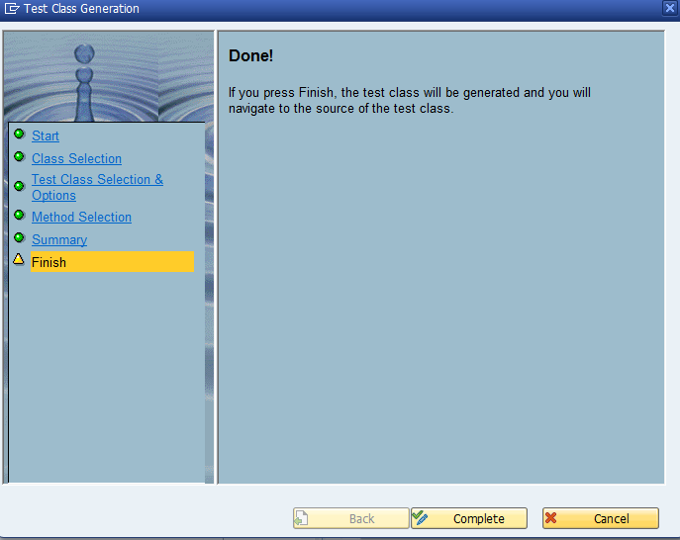

Then system will generate test class with test method as below

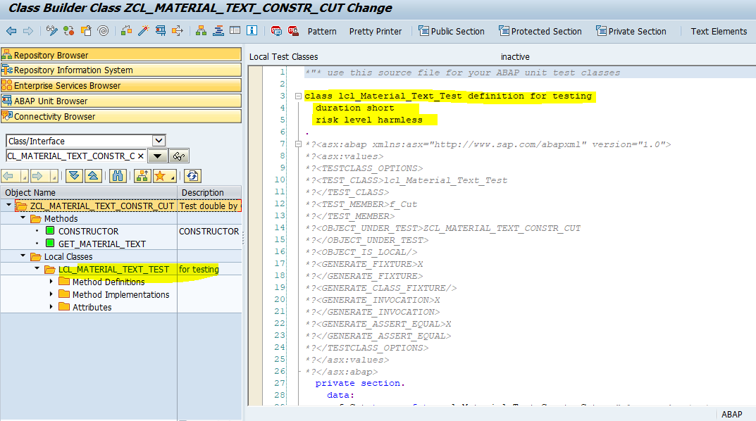

Activate class

In test case system is created object ‘f_cut’(Code under test) for accessing methods of class ‘**ZCL_MATERIAL_TEXT_CONSTR_CUT**’ and declare object ‘**f_Doa’** with reference to the interface name ‘**ZIF_MATERIAL_TEXT**’ for configure test double framework for dependence on component class

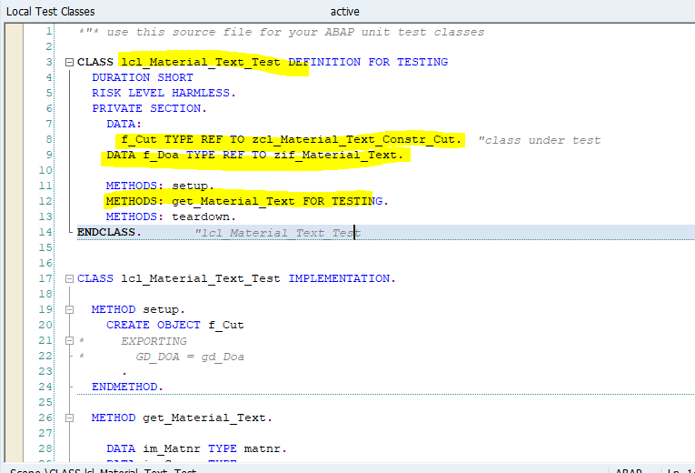

Create test double object in setup method as below

Class ‘**CL_ABAP_TESTDOUBLE**’ is used to create test double framework object by passing interface name ‘**ZIF_MATERIAL_TEXT**’ and assign this object to ‘**f_doa**’ using narrow casting and this object is used further for assigning test data to methods

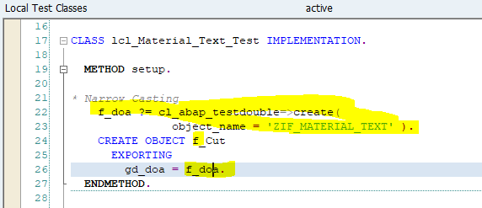

Remove memory allocated to object ‘**f_cut**’ and ‘**f_doa**’ in teardown method

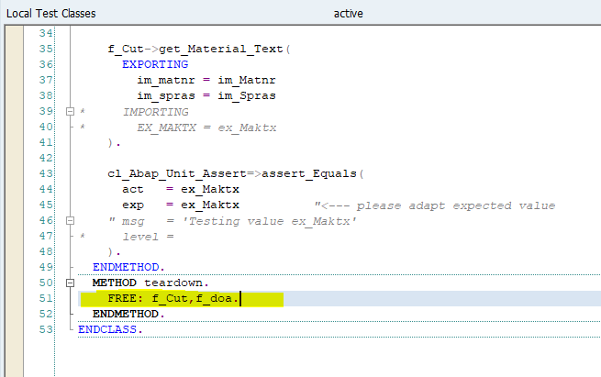

In test method declare variable ‘ACT_MAKTX’,’EXP_MAKTX’ with reference MAKT-MAKTX. Set default value 'Test Material' to variable ‘EXP’

Pass value 'Test Material' to ACT_MAKTX variable for to value exporting parameter ‘**EX_MAKTX**’ of method ‘get_material_text’ of interface ‘ZIF_MATERIAL_TEXT’ using ‘configure_call’ method of test double framework. Class method ‘**GET_MAYERIAL_TEST**’ of Interface ‘**ZIF_MATERIAL_TEXT**’ using test double framework object ‘**f_doa**’

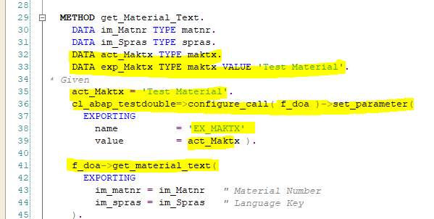

In when part calling method of code under test class for getting actual material test value and comparing actual and expected material value using method ‘**ASSERT_EAQUAL’** of class ‘**CL_ABAP_UNIT_ASSERT**” and clear value assigned to the variable ‘ACT_MATKX’as below

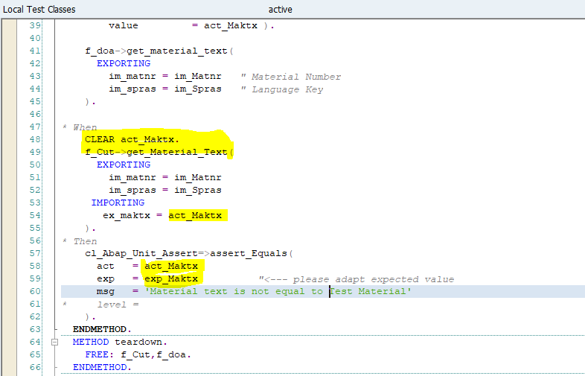

Now Given ,When and Then parts are completed. Execute unit test using shortcut ‘**Ctrl+Shift+F10**’ or use menu path ‘**Local test classes->Execute->Unit tests**’

This unit test is fail because not business logic written in method ‘**GET_MATERIAL_TEXT’** of code under test class ‘**ZCL_MATERIAL_TEXT_CONSTR_CUT**’

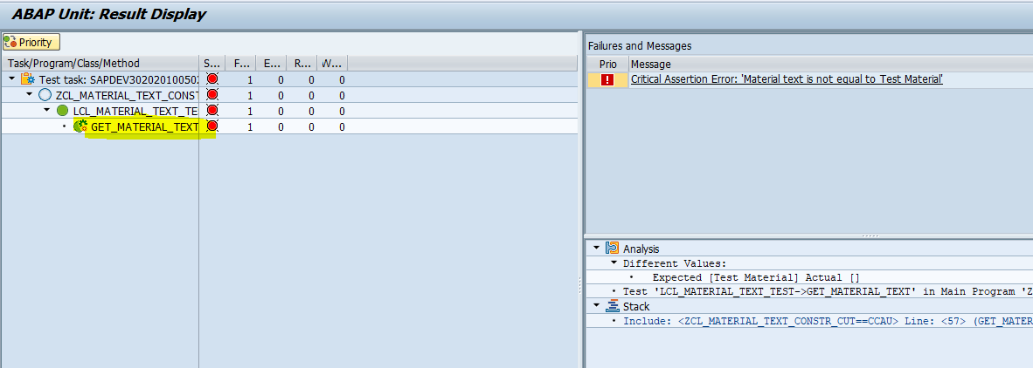

Go to Attributes tab of class and declare global variable ‘**GD_DOA’** as below

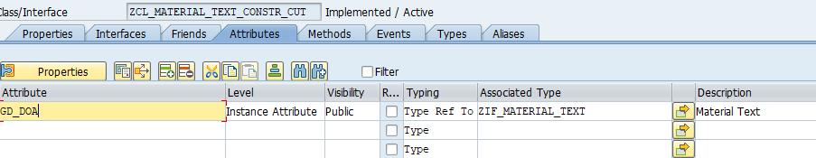

Go to Constructor method and write code as below

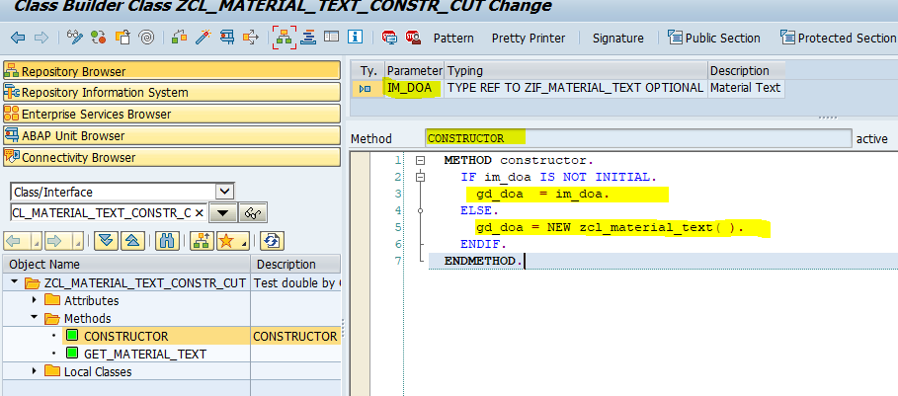

Add business logic code in method ‘GET_MATERIAL_TEXT’ as below to pass test case

Object is ‘**gd_doa’** is used to access method ‘**get_material_text’** of class ‘**ZCL_MATERIAL_TEXT**’

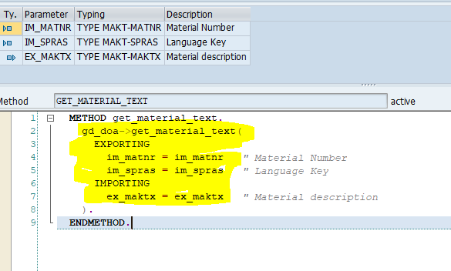

Activate class and execute unit test

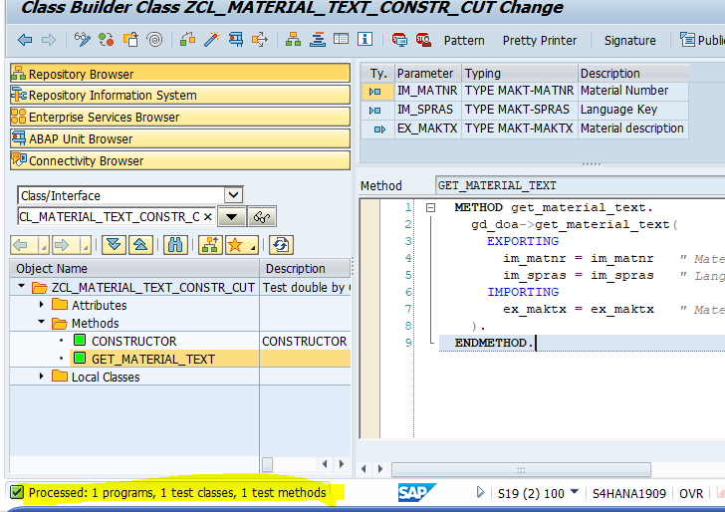

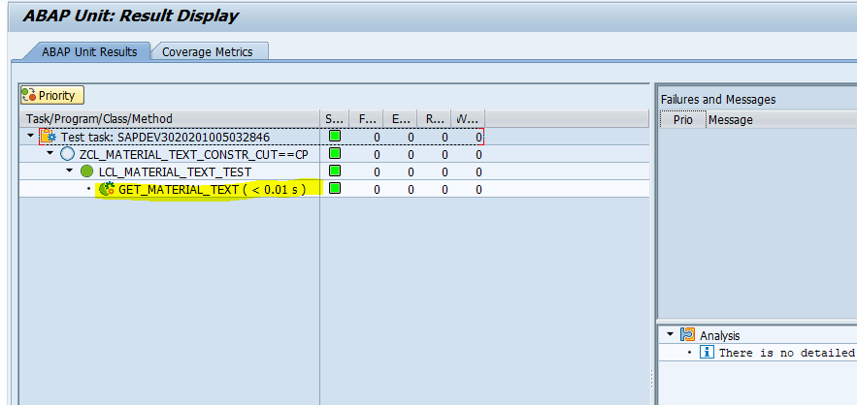

Now test is passed

##### Setter Injection

Setter Injection is same like as constructor injection. But in setter injection we will use setter method instead on constructor to set test double framework object in code under test class

Create new class ‘**ZCL_MATERIAL_TEXT_SETTER_CUT**’ in SE24. follow Constructor injection steps

Instead of Constructor add method ‘**Set_Object’** in class ‘ZCL_MATERIAL_TEXT_SETTER_CUT’.

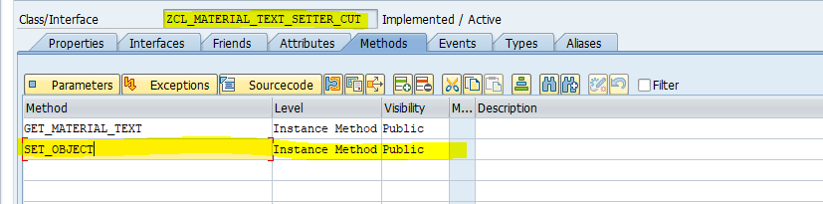

Add importing parameter ‘**im_doa’** with reference to the interface ‘**ZIF_MATERIAL_TEXT’**

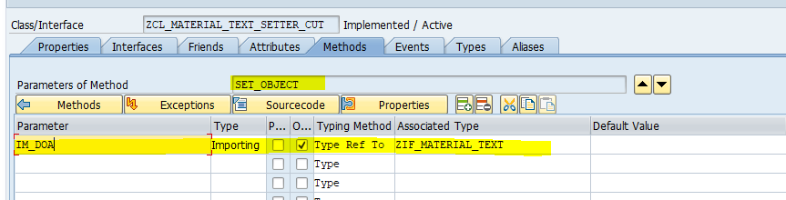

And write below logic to assign object to global object ‘**GD_DOA’** as below

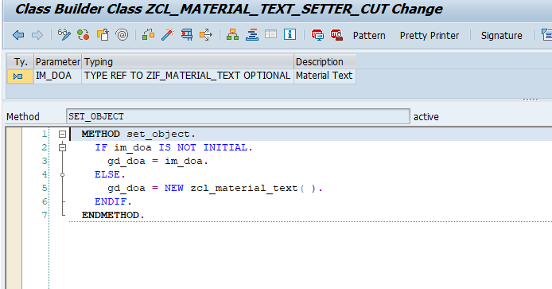

Follow constructor injection steps to create local test class

Local test class ‘LCL_MATERIAL_TEXT_SETTER_TEST’ is created and Object ‘**f_doa**’ is declared and created using test double framework.

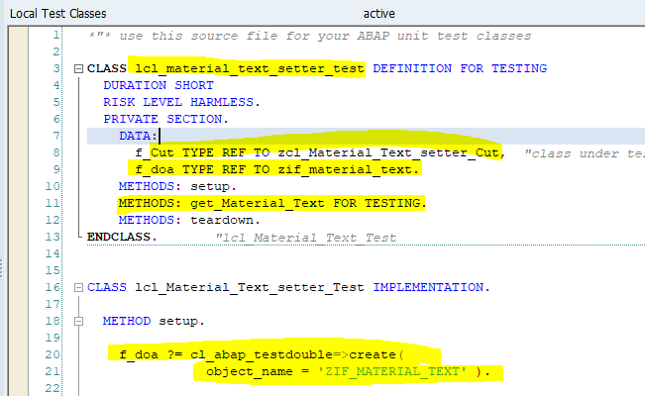

Call method ‘**set_object**’ to assign test double object to global object ‘**GD_DOA’** by passing object ‘**F_CUT’** as below

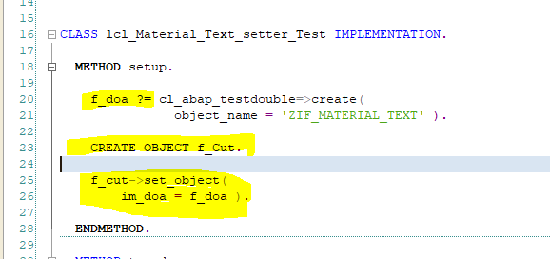

Rest all coding same as constructor injection

Execute unit test using shortcut ‘**Ctrl+Shift+F10**’ or use menu path ‘**Local test classes->Execute->Unit tests**’

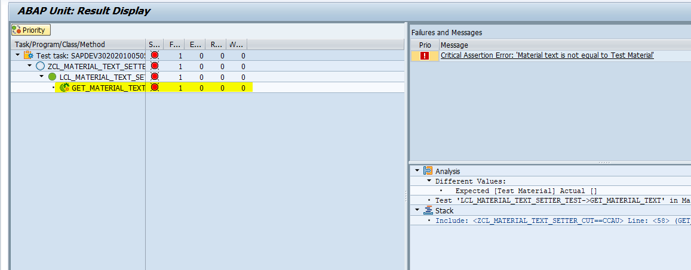

Test unit case is fail because there is not business logic inside method ‘**GET_MATERIAL_TEXT’** of code under class ‘**ZCL_MATERIAL_TEXT_SETTER_CUT**’. Write below logic in method

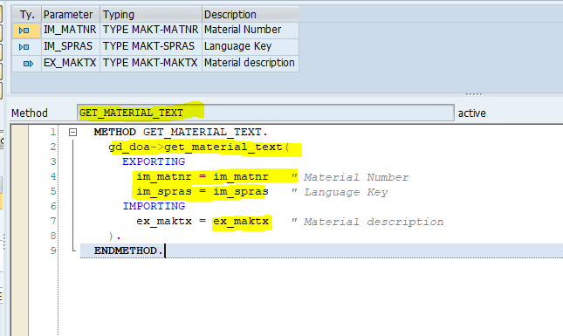

Activate class

Execute unit test case again

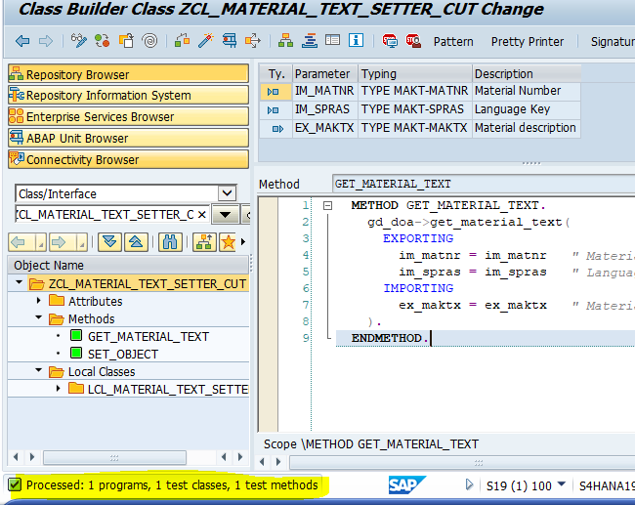

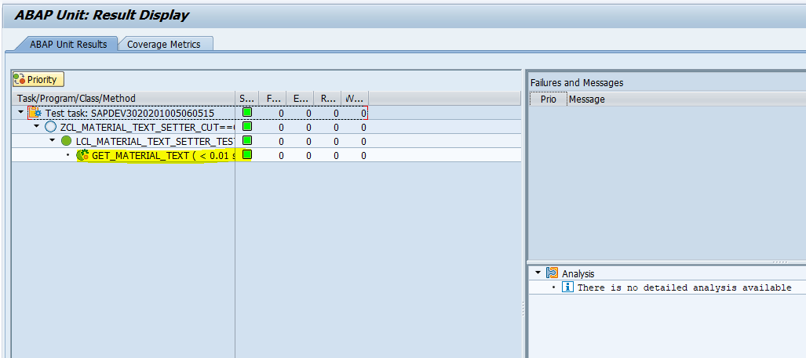

Now test cases is passed

##### Parameter Injection

In parameter injection, we are passing object of dependent of component as ‘**ZIF_MATERIAL_TEXT**’ in code under class method instead of constructor or Setter method.

Follow steps of constructor injection to create class ‘**ZCL_MATERIAL_TEXT_PARA_CUT**’ and add method ‘**GET_MATERIAL_TEXT**’ with same importing exporting parameter from Constructor injection and Add one import parameter ‘IM_DOA’ with reference to the interface ‘**ZIF_MATERIAL_TEXT**’ as below

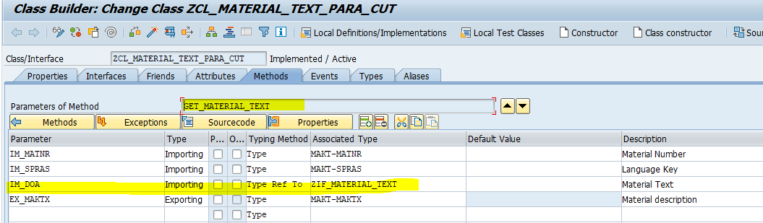

Follow steps from Constructor injection to create Test class.

I have created test class ‘LCL_MATERIAL_TEXT_PARA_TEST’ with setup, teardown and test method ‘get_Material_Text’ . aslo ‘**f_doa**’ is declared and created using test double framework and Object is created in Setup method using class ‘**CL_ABAP_TESTDOUBLE**’

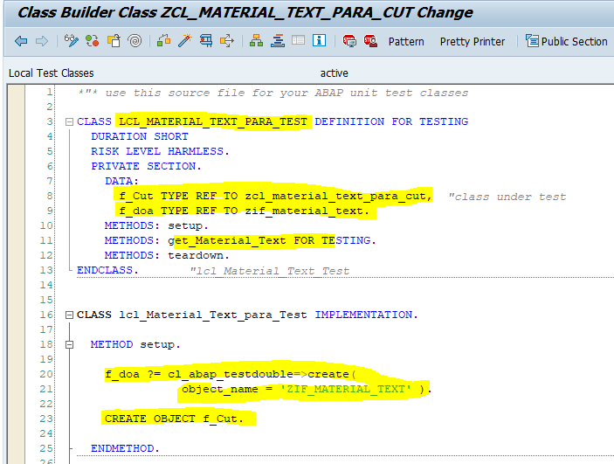

Pass the ‘F_DOA’ object to exporting parameter ‘IM_DOA’ of code under test class while calling from test method of test class as below.

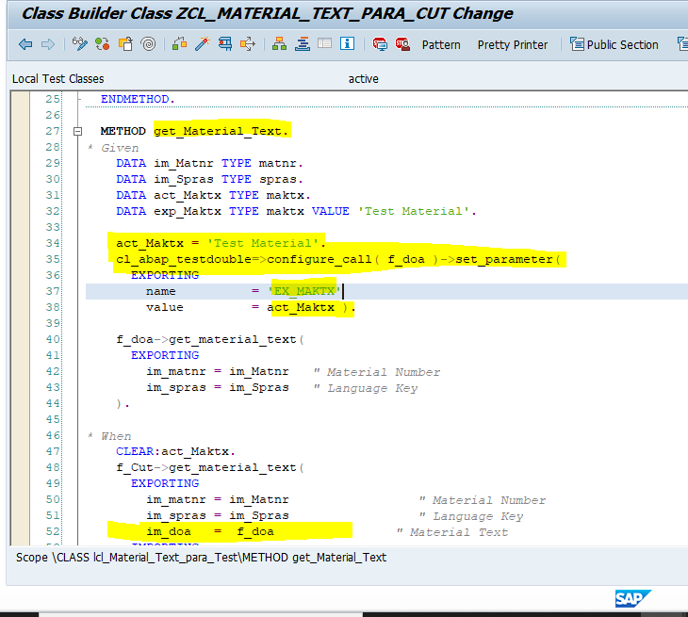

Activate class

Execute unit test using shortcut ‘**Ctrl+Shift+F10**’ or use menu path ‘**Local test classes->Execute->Unit tests**’

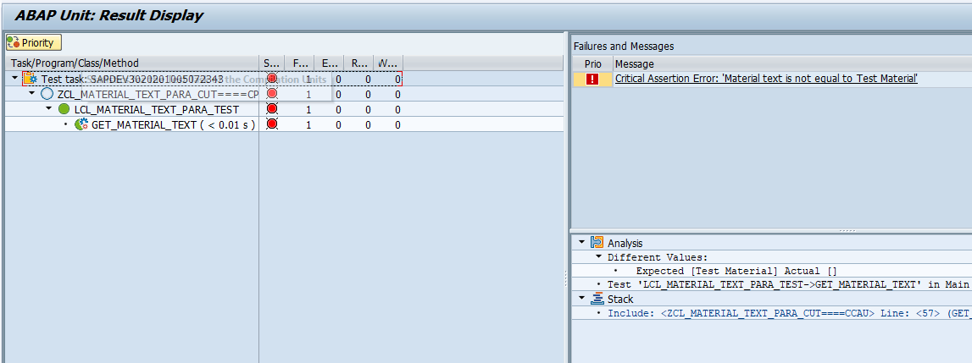

Test unit case is fail because there is not business logic inside method ‘**GET_MATERIAL_TEXT’** of code under class ‘**ZCL_MATERIAL_TEXT_PARA_CUT’**. Write below logic in method

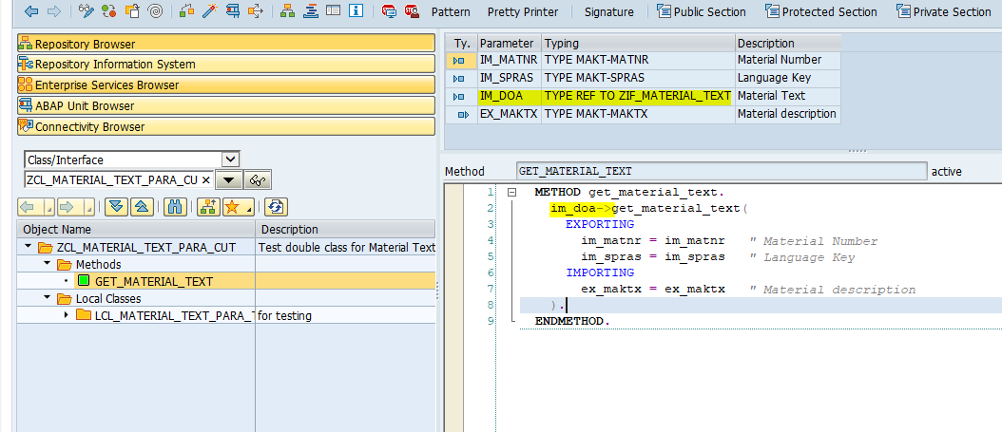

Import parameter ‘**IM_DOA’** is used to call method ‘**GET_MATERIAL_TEXT’** from class ‘**ZCL_MATERIAL_TEXT’**

Execute unit test again

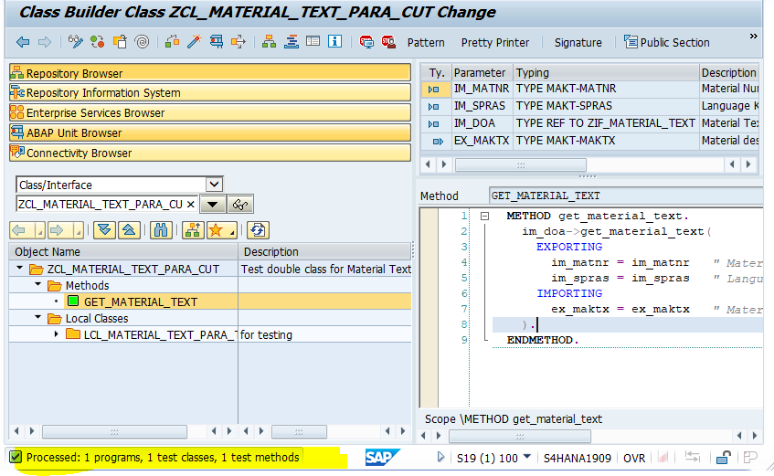

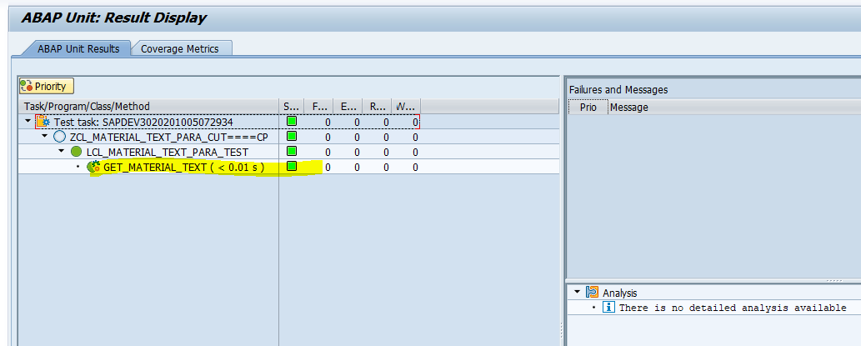

Now test case is passed

##### Backdoor Injection

Backdoor injection is used to access private member of the code under class.

Create class ‘**ZCL_MATERIAL_TEXT_BACK_CUT’** in SE24 and declare Global Attribute ‘GD_DOA’ is as private in class.

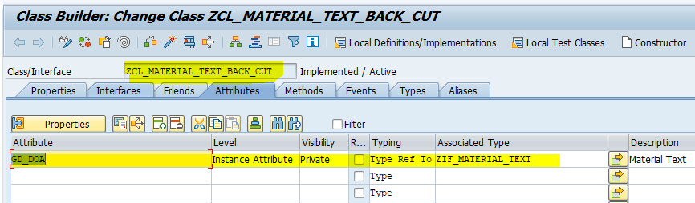

Add method ‘GET_MATERIAL_TEXT’ with importing and exporting parameter as below

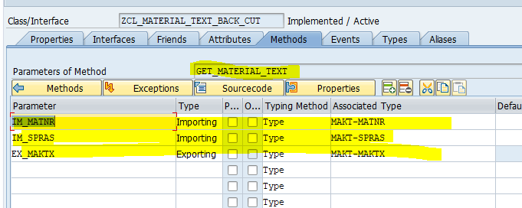

Follow steps of constructor injection to create local test class ‘**lcl_Material_Text_back_Test**’

I have created local test class as below with setup, teardown, get_material_text method and object ‘**F_CUT**’ with reference to the code under test class ‘**ZCL_MATERIAL_TEXT_BACK_CUT**’ and ‘**F_DOA**” with reference to the Interface ‘**ZIF_MATERIAL_TEXT**’

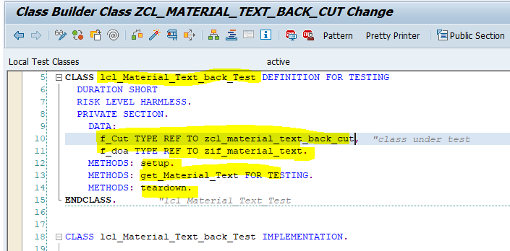

Make local friendship with class ‘ZCL_MATERIAL_TEXT_BACK_CUT’ for access private member of the class as below.

Then global object ‘GD_DOA’ will access in local test class

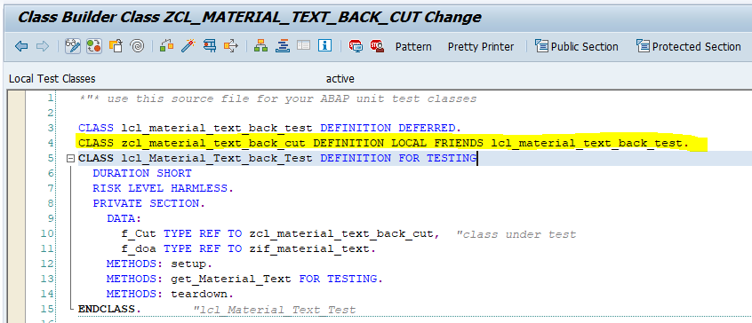

Create test double framework for Interface ‘**ZIF_MATERIAL_TEXT**’ in setup method using class **CL_ABAP_TESTDOUBLE**  and pass test double object to global object ‘GD_DOA’ as below

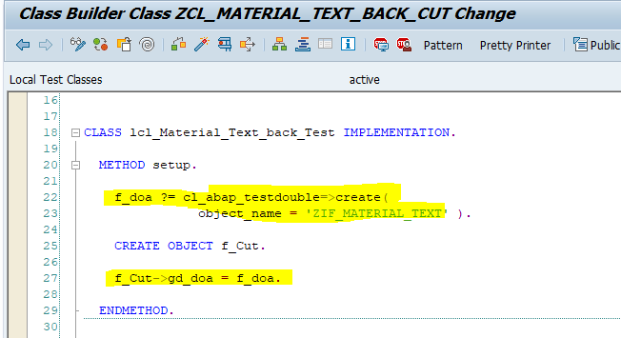

Write Given ,when,Then, pass test data for exporting parameter ‘EX_MAKTX’ using test double method ‘**Configuration_call**’ as below

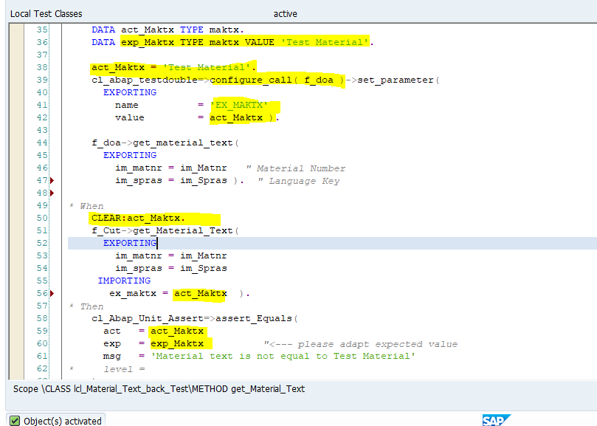

Activate class

Execute unit test using shortcut ‘**Ctrl+Shift+F10**’ or use menu path ‘**Local test classes->Execute->Unit tests**’

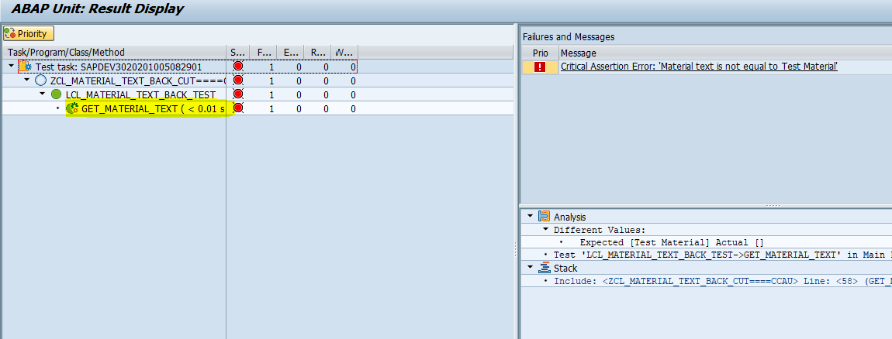

Test unit case is fail because there is not business logic inside method ‘**GET_MATERIAL_TEXT’** of code under class ‘**ZCL_MATERIAL_TEXT_BACK_CUT**. Write below code in method.

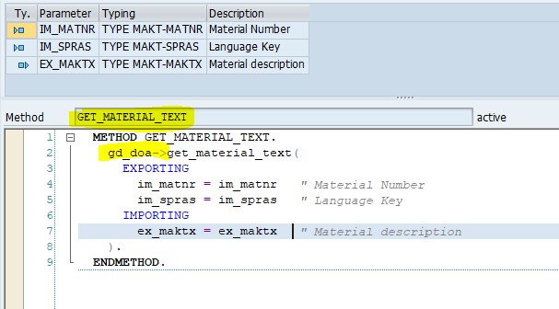

Execute unit test again

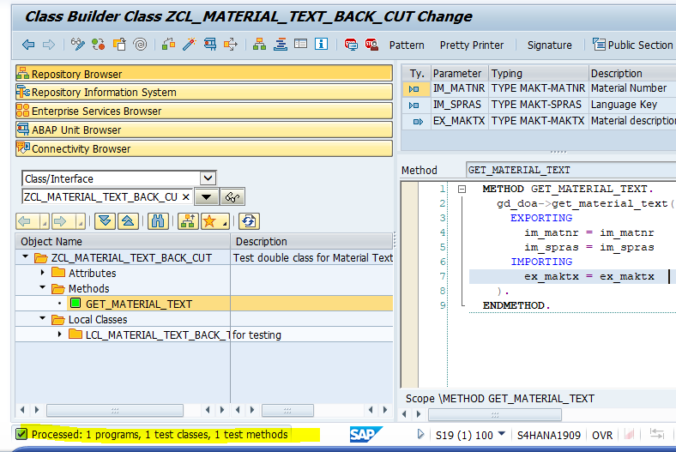

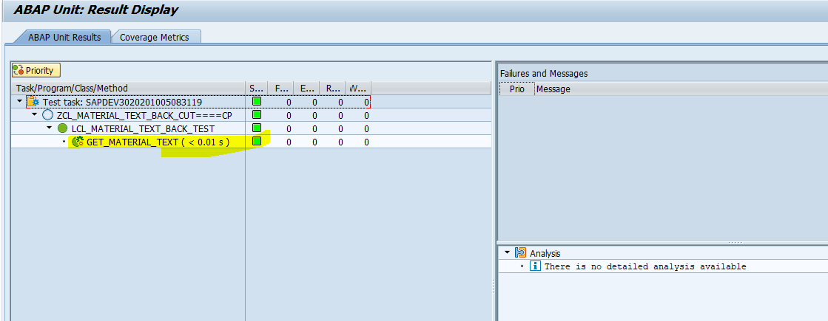

Now test is passed

### Bottom –Up Approach

#### Constructor Injection

Create class ‘**ZCL_MATERIAL_TEXT_CONSTR_CUT1’** in SE24 and add description as below

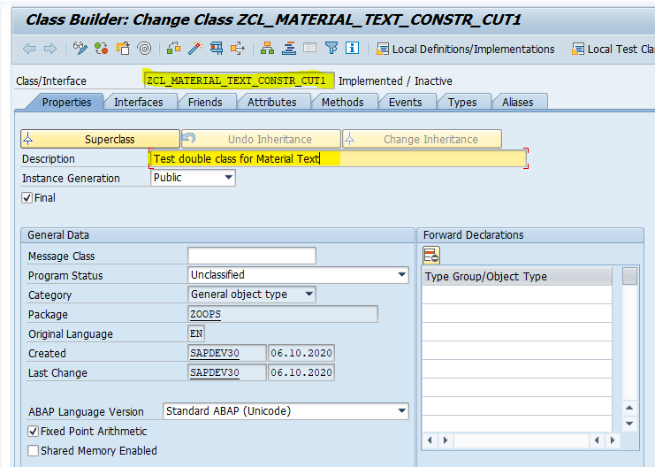

Go to Local test classes button to write local test class

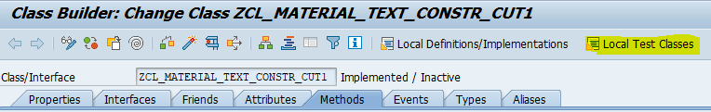

Write local test class ‘**lcl_material_text_constr_test1**’ with duration, risk level and fixture method as below

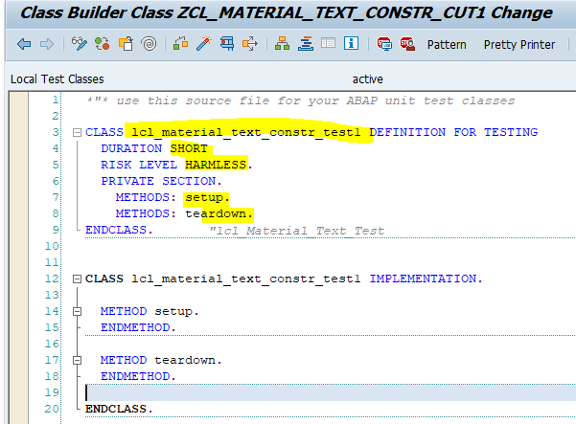

Declare test method ‘**get_Material_Text**’ in class definition and Implement as below

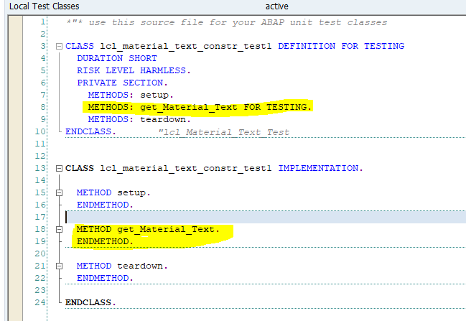

Add Given, When, Then in test method as below

In Given part , We are passing Material no and language with exporting variable ‘**IM_MATNR**’ and ‘**IM_SPRAS**’ and expected material text is ‘**Small Part, Slow-Moving Item**’.

In When part, declaring product method to return actual material text in ‘**ACT_MAKTX**’

In Then part, Comparing actual and expected result by assert method ‘**ASSERT_EQUALS**’

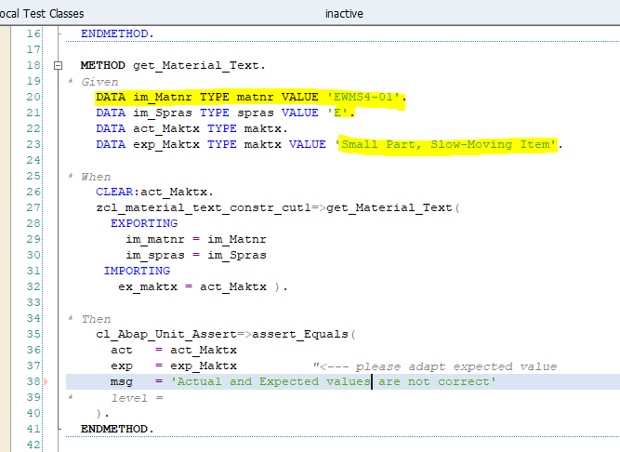

Double click on method ‘**Get_material_text**’ to create in product class then below pop-up will come

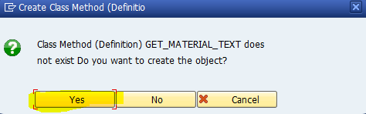

Click on Yes button

Enter Description, select public as visibility and static as method

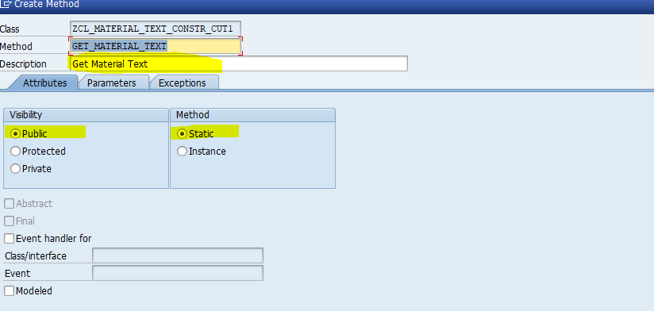

Enter importing and exporting parameter in parameter tab as below

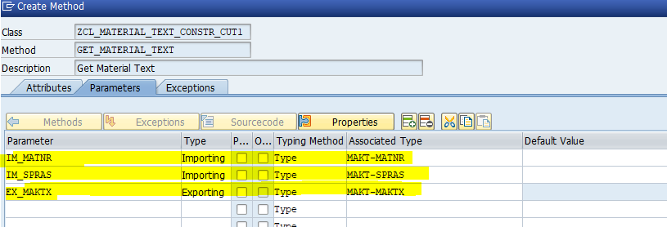

And click on create button.

Now method is created in product class

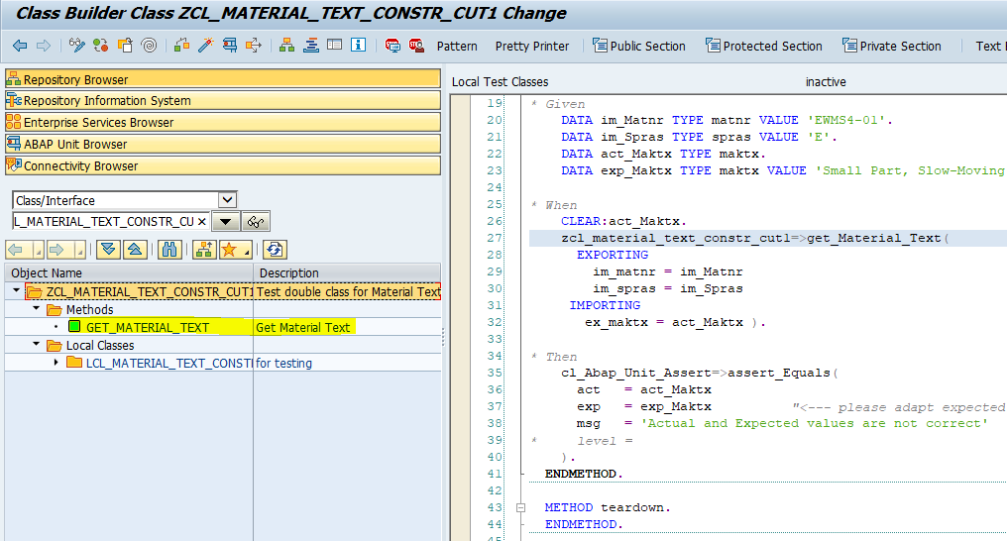

Activate class

Execute Unit test case by shortcut **‘Ctrl+Shift+F10’** or menu path ‘**Local test classes->Execute->Unit Tests**’

Unit test case is fail because no product exists inside the product method

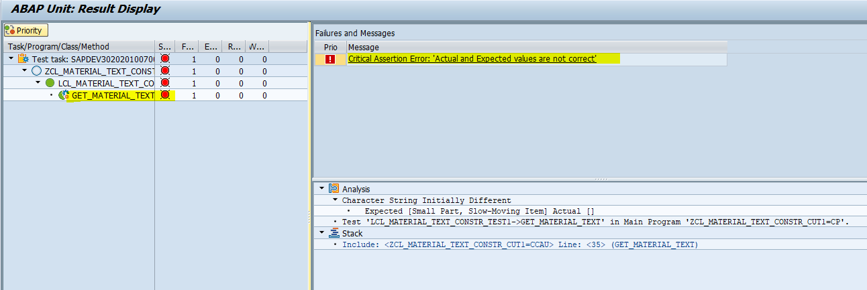

Add product inside product method to pass test case as below

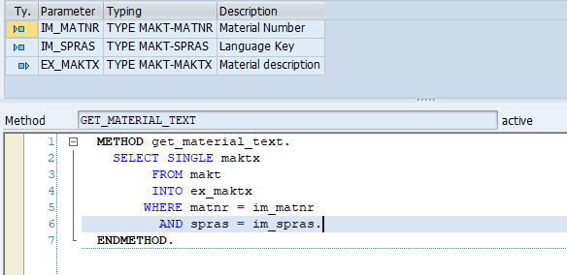

Once again execute unit test

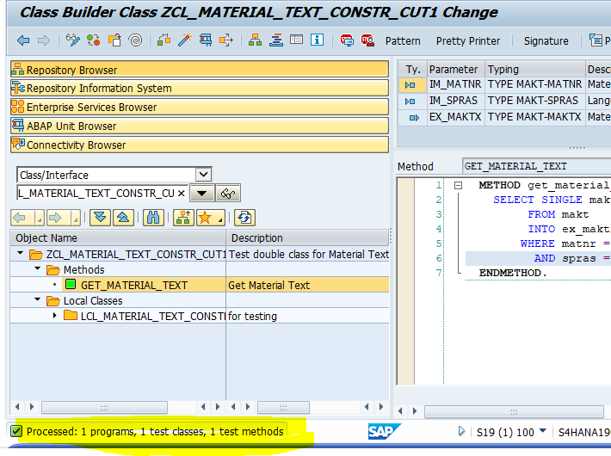

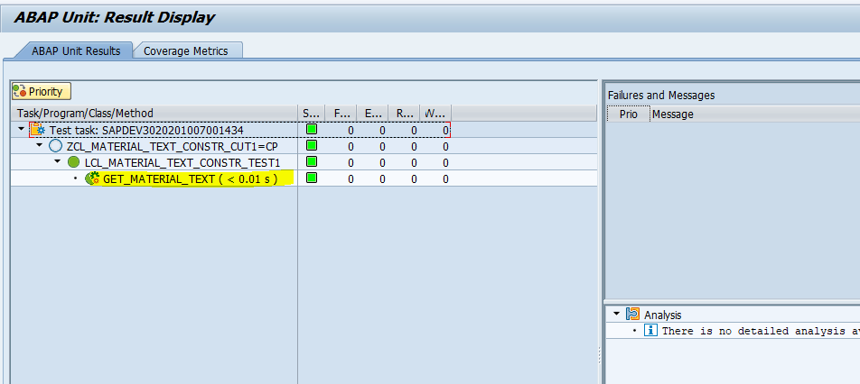

Now test case is passed

Select query is for select material text is depending on the database, If there is some changes going on database layer then we will not able test our unit test

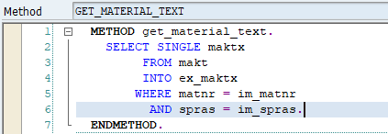

For that, we need to refactor code and use test double framework to break dependency of object

##### Interface & Class

Create Interface ‘**ZIF_MATERIAL_TEXT1**’ to configure test double framework.

Go to SE24 , Enter Interface name ‘**ZIF_MATERIAL_TEXT1**’ and click on create button.

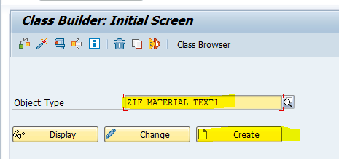

Enter description

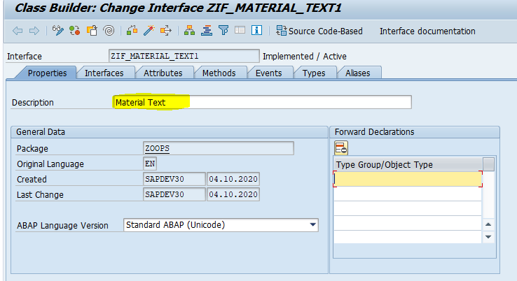

Enter method ‘**GET_MATERIAL_TEXT**’

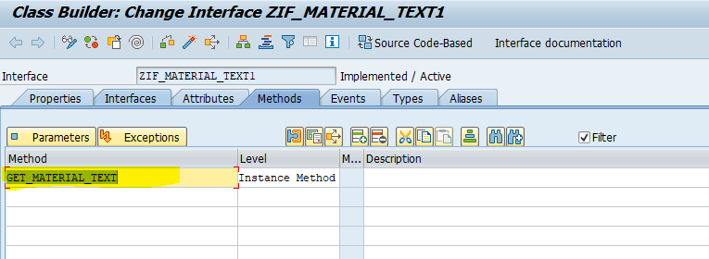

Enter importing and exporting parameter to method as below

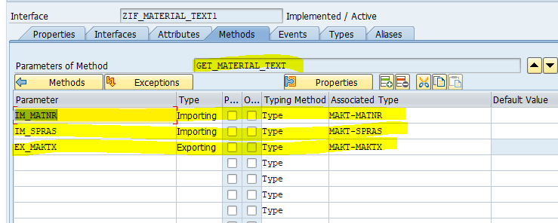

Activate Interface

Create class’ **ZCL_MATERIAL_TEXT1**’ for implement Interface ‘**ZIF_MATERIAL_TEXT1**’.

Create class ‘**ZCL_MATERIAL_TEXT1**’ in SE24 and Enter description.

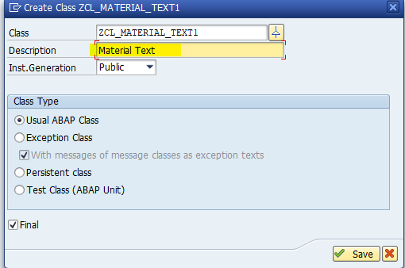

Click on save

Enter Interface name in Interface tab as below

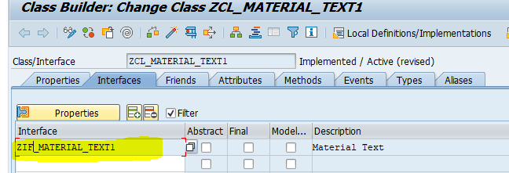

Go to method and double click on it to implements

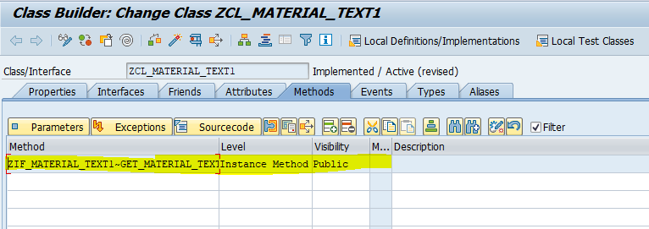

And select query to get material text

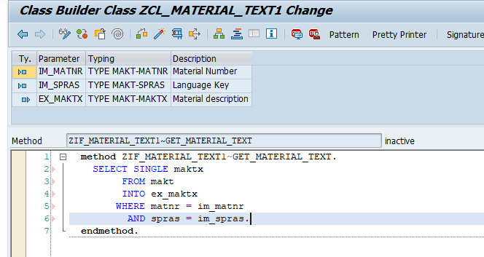

Activate class

Go to class local test class of class ‘**ZCL_MATERIAL_TEXT_CONSTR_CUT1**’ and declare object ‘**F_DOA’** with reference to ‘**ZIF_MATERIAL_TEXT1**’ and ‘**f_cut**’ with reference to the ‘**ZCL_MATERIAL_TEXT_CONSTR_CUT1**’ in definition as below

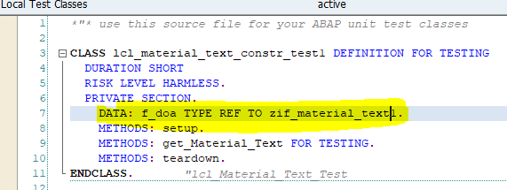

Create test double framework in setup method as below

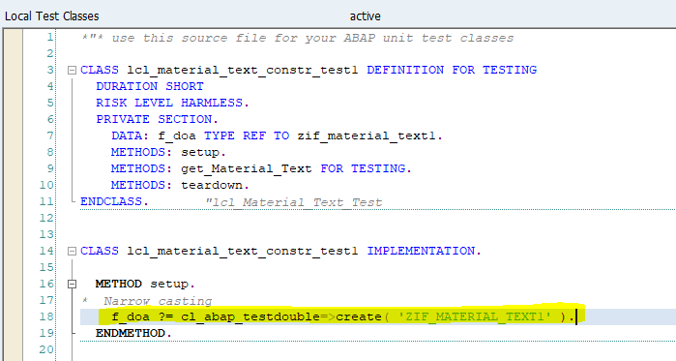

Create global attribute ‘**GD_DOA**’ with reference to the ‘**ZIF_MATERIAL_TEXT1**’ in product class

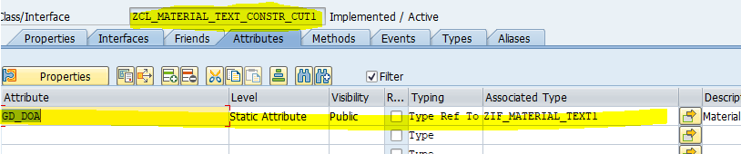

Add constructor in method tab by click on constructor menu button

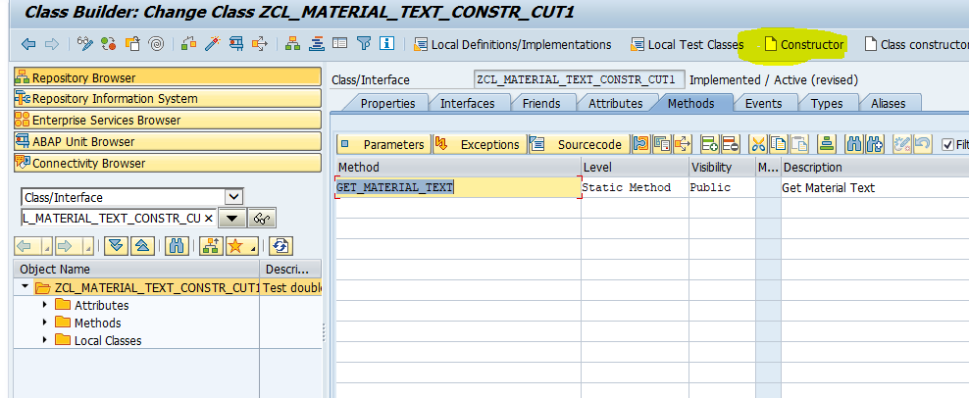

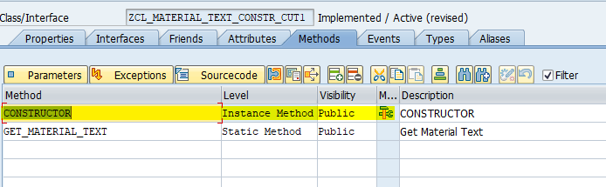

And importing parameter ‘**IM_DOA**’ with reference to the ‘**ZIF_MATERIAL_TEXT1**’ in constructor as below

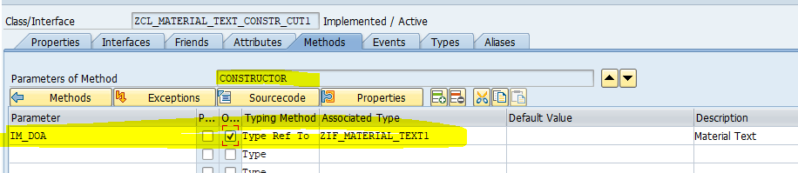

Add below logic in constructor

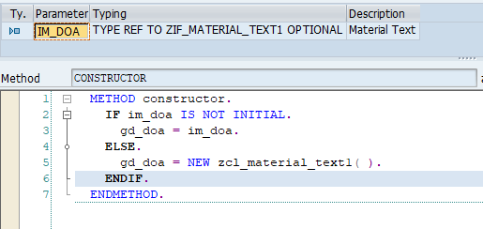

Declare object ‘**F_CUT**’ with reference to ‘**ZCL_MATERIAL_TEXT_CONSTR_CUT1**’ in test class definition as below

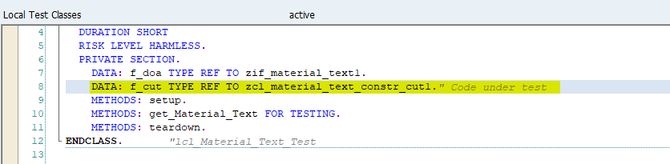

Create object ‘F_CUT’ in setup method and pass test double object to exporting parameter ‘IM_DOA’ of constructor as below

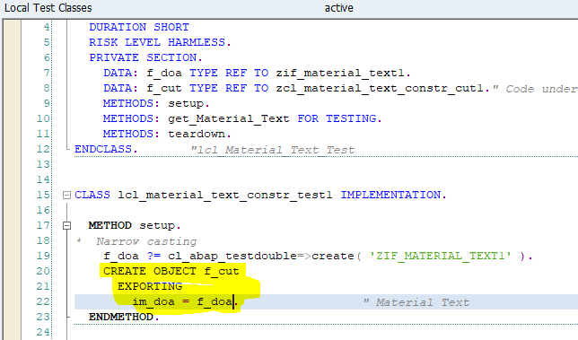

In test method pass test data to exporting parameter ‘**EX_MAKTX**’ using test double parameter as below

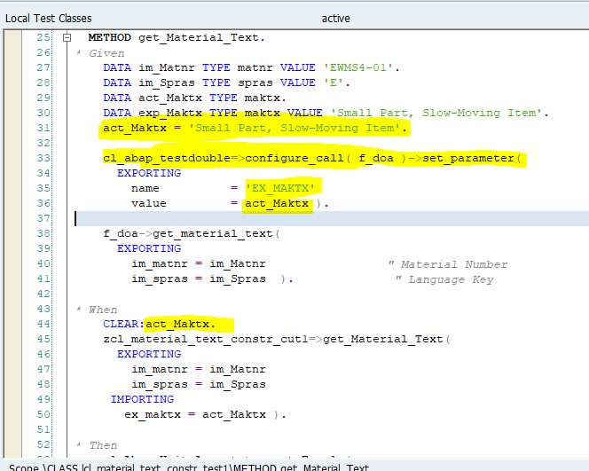

Go to product method ‘**Get_material_text’** of product class ‘**ZCL_MATERIAL_TEXT_CONSTR_CUT1**’ and change logic to get data from class ‘**ZCL_MATRIAL_TEXT1**’ as below.

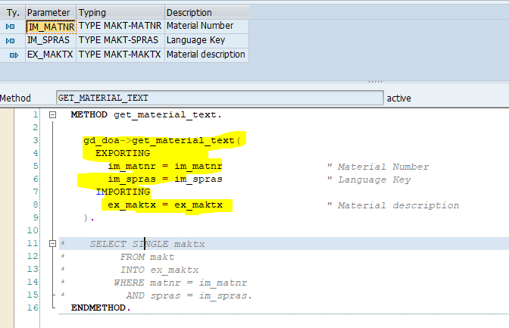

Activate class

Execute unit test

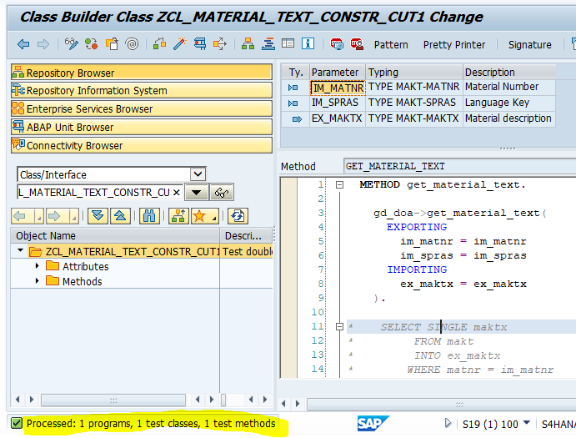

This Test case is passed and it is getting test data from test double framework

#### Setter Injection

Create class ‘**ZCL_MATERIAL_TEXT_SETTER_CUT1’** in SE24 and add description as below

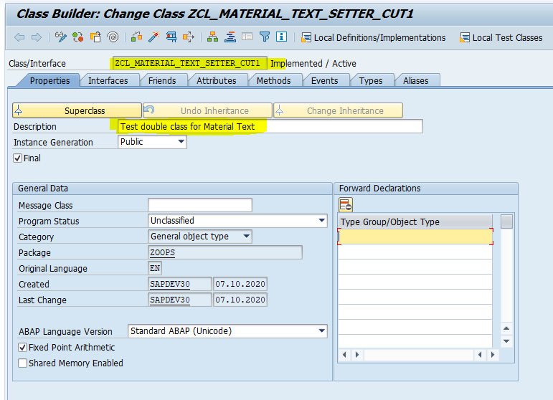

Go to Local test classes button to write local test class



Write local test class ‘**lcl_material_text_setter_test1**’ with duration, risk level and fixture method as below

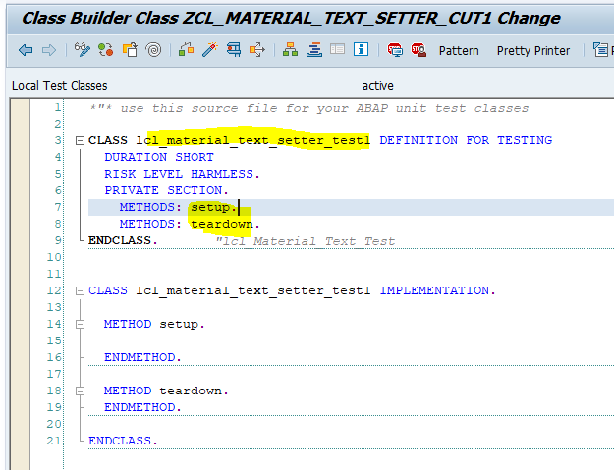

Declare test method ‘**get_Material_Text**’ in class definition and Implement as below

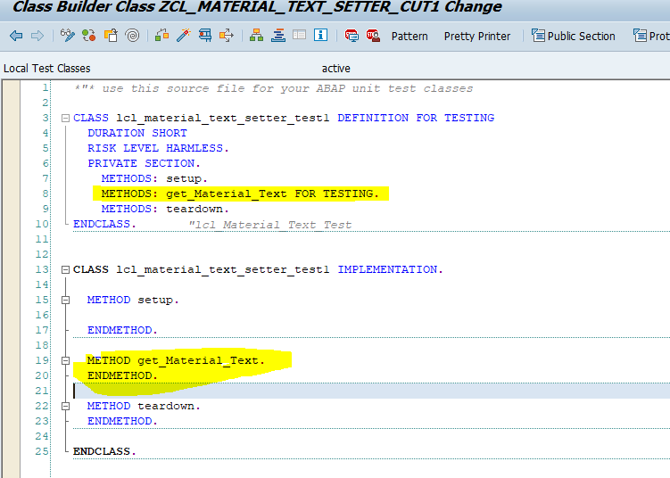

Add Given, When, Then in test method as below

In Given part , We are passing Material no and language with exporting variable ‘**IM_MATNR**’ and ‘**IM_SPRAS**’ and expected material text is ‘**Small Part, Slow-Moving Item**’.

In When part, declaring product method to return actual material text in ‘**ACT_MAKTX**’

In Then part, Comparing actual and expected result by assert method ‘**ASSERT_EQUALS**’



Double click on method ‘**Get_material_text**’ to create in product class then below pop-up will come



Click on Yes button

Enter Description, select public as visibility and static as method

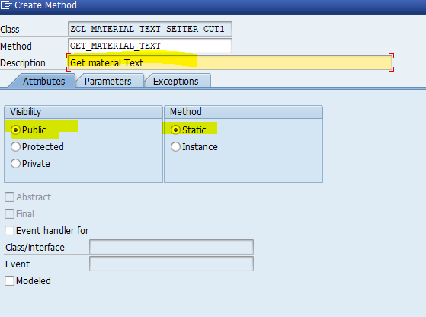

Enter importing and exporting parameter in parameter tab as below

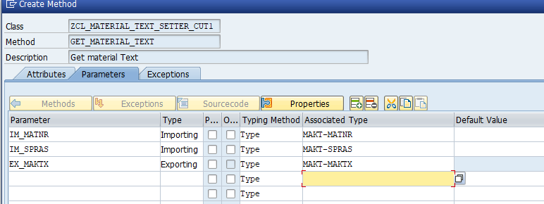

And click on create button.

Now method is created in product class

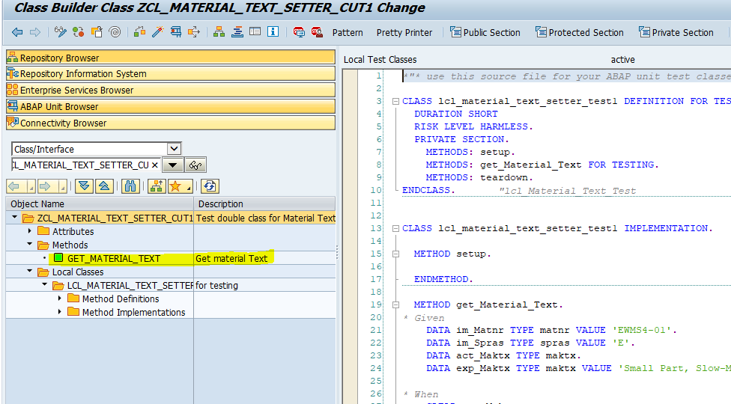

Activate class

Execute Unit test case by shortcut **‘Ctrl+Shift+F10’** or menu path ‘**Local test classes->Execute->Unit Tests**’

Unit test case is fail because no product exists inside the product method

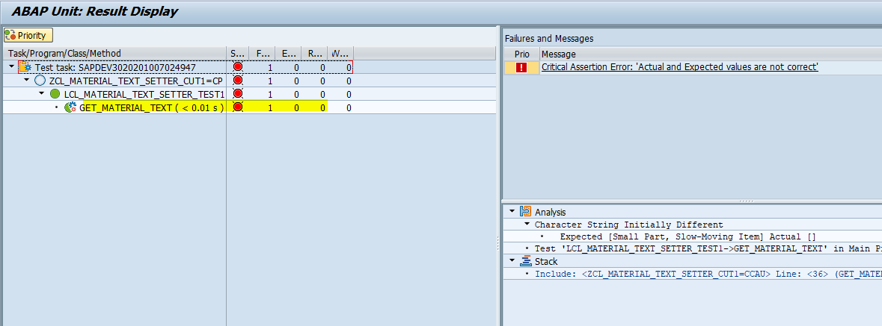

Add product inside product method to pass test case as below



Once again execute unit test

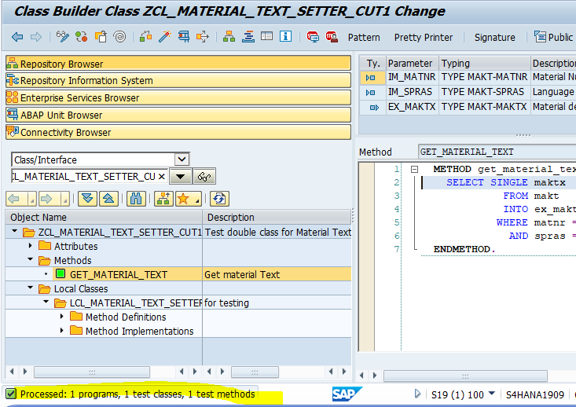

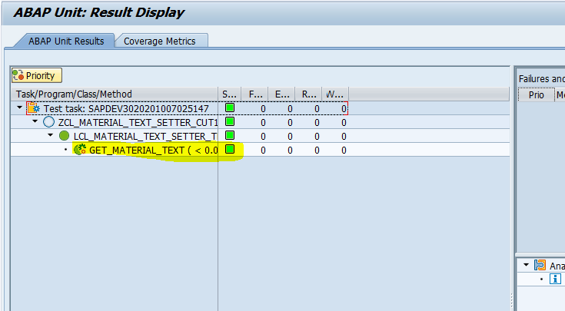

Now test case is passed

Select query is for select material text is depending on the database, If there is some changes going on database layer then we will not able test our unit test



For that, we need to refactor code and use test double framework to break dependency of object

##### Interface & Class

Create Interface ‘**ZIF_MATERIAL_TEXT1**’ to configure test double framework.

Go to SE24 , Enter Interface name ‘**ZIF_MATERIAL_TEXT1**’ and click on create button.



Enter description



Enter method ‘**GET_MATERIAL_TEXT**’



Enter importing and exporting parameter to method as below



Activate Interface

Create class’ **ZCL_MATERIAL_TEXT1**’ for implement Interface ‘**ZIF_MATERIAL_TEXT1**’.

Create class ‘**ZCL_MATERIAL_TEXT1**’ in SE24 and Enter description.



Click on save

Enter Interface name in Interface tab as below



Go to method and double click on it to implements



And select query to get material text



Activate class

Go to class local test class of class ‘**ZCL_MATERIAL_TEXT_SETTER_CUT1**’ and declare object ‘**F_DOA’** with reference to ‘**ZIF_MATERIAL_TEXT1**’ and ‘**f_cut**’ with reference to the ‘**ZCL_MATERIAL_TEXT_SETTER_CUT1**’ in definition as below

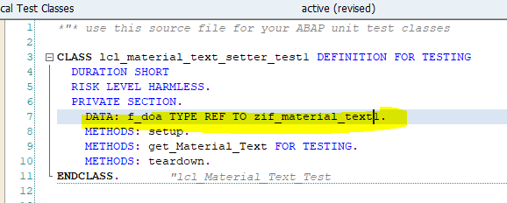

Create test double framework in setup method as below

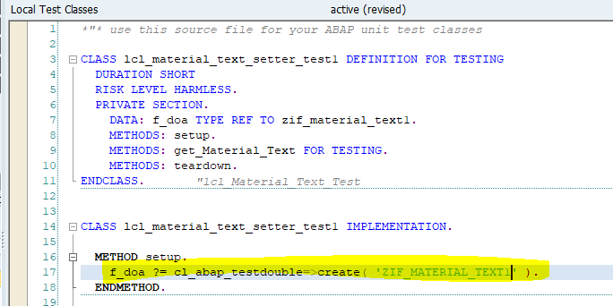

Create global attribute ‘**GD_DOA**’ with reference to the ‘**ZIF_MATERIAL_TEXT1**’ in product class

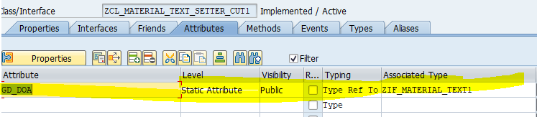

Add ‘**set_object**’ method in method tab by click on constructor menu button

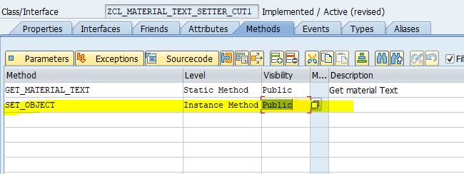

And importing parameter ‘**IM_DOA**’ with reference to the ‘**ZIF_MATERIAL_TEXT1**’ in constructor as below

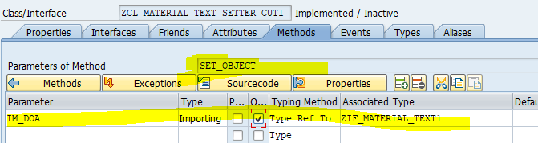

Add below logic in constructor

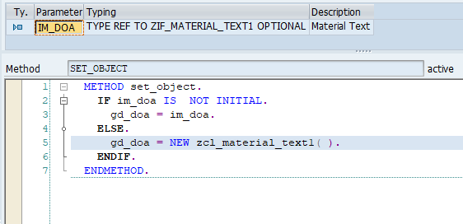

Declare object ‘**F_CUT**’ with reference to ‘**ZCL_MATERIAL_TEXT_SETTER_CUT1 ‘**in test class definition as below

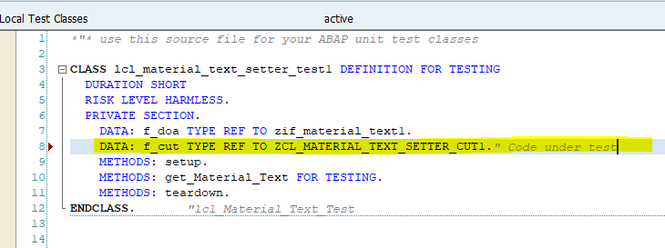

Create object ‘F_CUT’ in setup method and call method ‘**Set_object**’ of product class and pass test double object to exporting parameter ‘IM_DOA’ of method as below

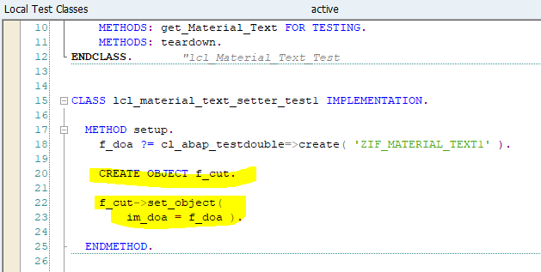

In test method pass test data to exporting parameter ‘**EX_MAKTX**’ using test double parameter as below

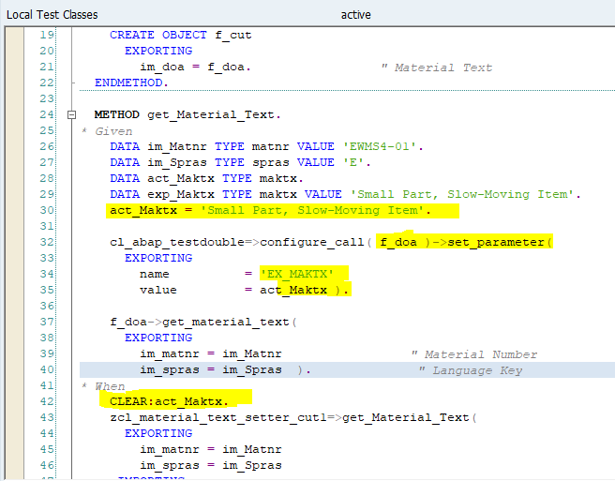

Go to product method ‘**Get_material_text’** of product class ‘**ZCL_MATERIAL_TEXT_SETTER_CUT1**’ and change logic to get data from class ‘**ZCL_MATRIAL_TEXT1**’ as below.

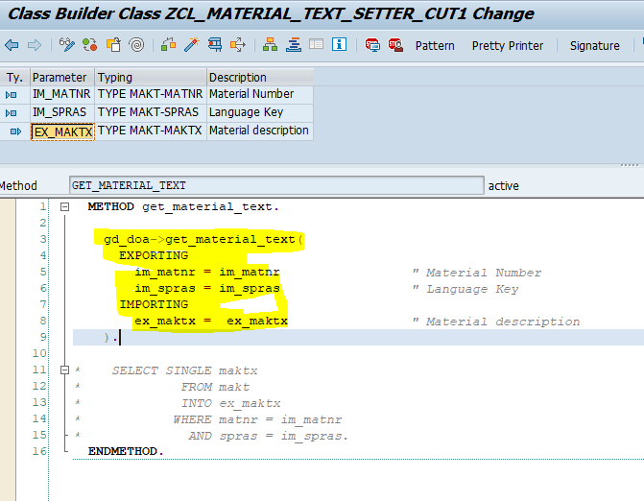

Activate class

Execute unit test

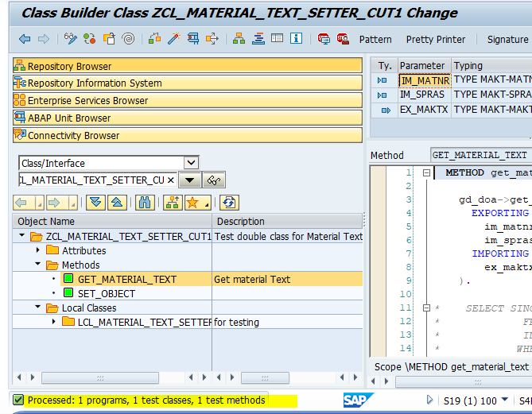

This Test case is passed and it is getting test data from test double framework

#### Parameter Injection

Create class ‘**ZCL_MATERIAL_TEXT_PARA_CUT1’**in SE24 and add description as below

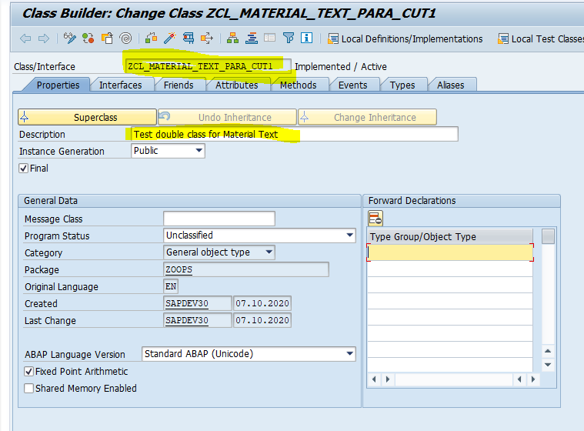

Go to Local test classes button to write local test class



Write local test class ‘**lcl_material_text_para_test1**’ with duration, risk level and fixture method as below

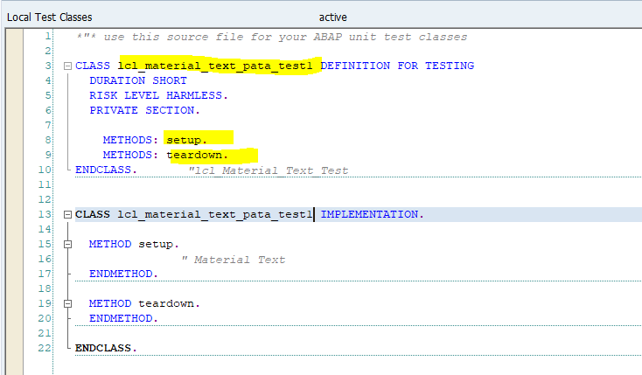

Declare test method ‘**get_Material_Text**’ in class definition and Implement as below

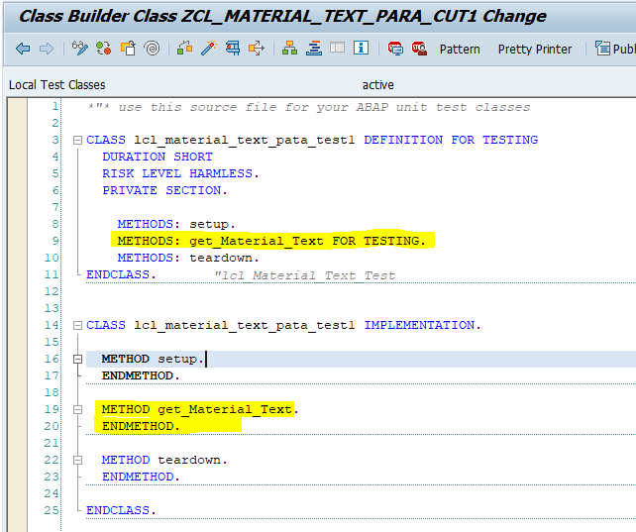

Add Given, When, Then in test method as below

In Given part , We are passing Material no and language with exporting variable ‘**IM_MATNR**’ and ‘**IM_SPRAS**’ and expected material text is ‘**Small Part, Slow-Moving Item**’.

In When part, declaring product method to return actual material text in ‘**ACT_MAKTX**’

In Then part, Comparing actual and expected result by assert method ‘**ASSERT_EQUALS**’

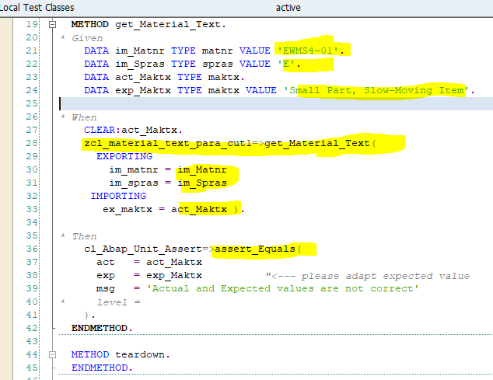

Double click on method ‘**Get_material_text**’ to create in product class then below pop-up will come



Click on Yes button

Enter Description, select public as visibility and static as method

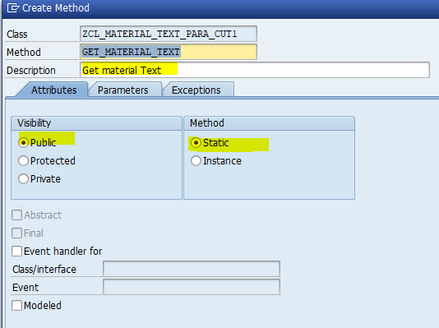

Enter importing and exporting parameter in parameter tab as below

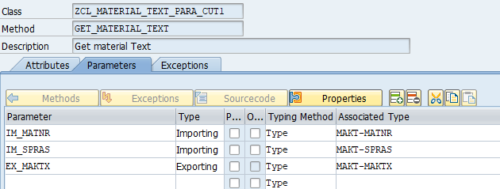

And click on create button.

Now method is created in product class

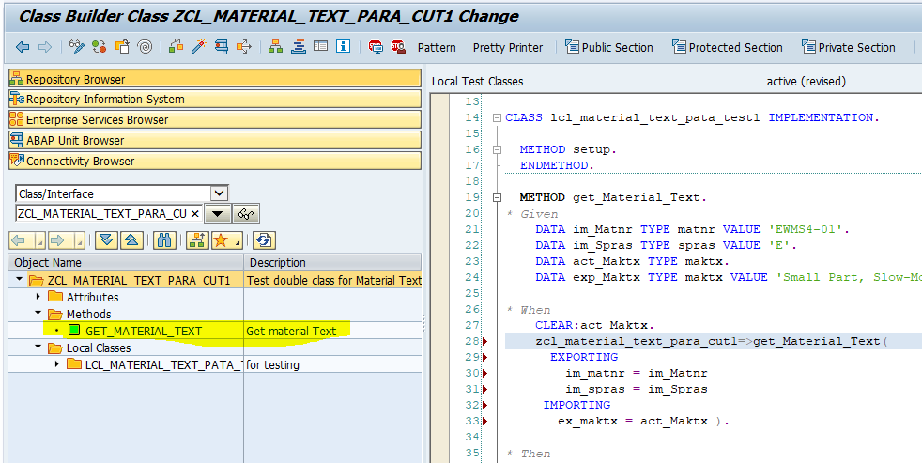

Activate class

Execute Unit test case by shortcut **‘Ctrl+Shift+F10’** or menu path ‘**Local test classes->Execute->Unit Tests**’

Unit test case is fail because no product exists inside the product method

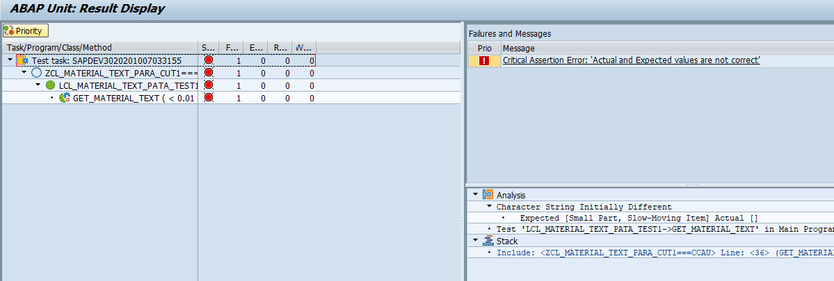

Add product inside product method to pass test case as below



Once again execute unit test

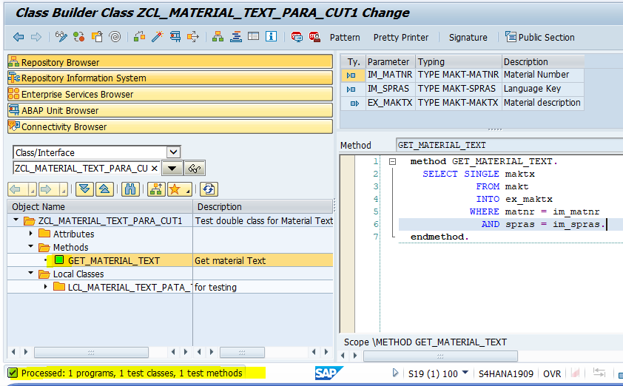

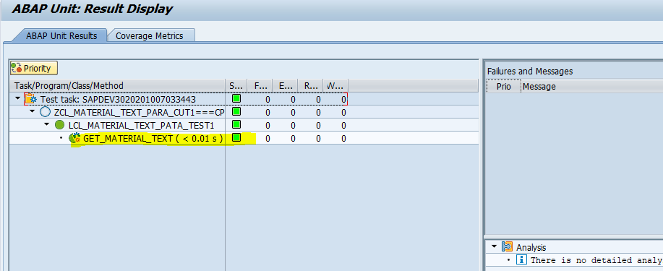

Now test case is passed

Select query is for select material text is depending on the database, If there is some changes going on database layer then we will not able test our unit test



For that, we need to refactor code and use test double framework to break dependency of object

##### Interface & Class

Create Interface ‘**ZIF_MATERIAL_TEXT1**’ to configure test double framework.

Go to SE24 , Enter Interface name ‘**ZIF_MATERIAL_TEXT1**’ and click on create button.



Enter description



Enter method ‘**GET_MATERIAL_TEXT**’



Enter importing and exporting parameter to method as below



Activate Interface

Create class’ **ZCL_MATERIAL_TEXT1**’ for implement Interface ‘**ZIF_MATERIAL_TEXT1**’.

Create class ‘**ZCL_MATERIAL_TEXT1**’ in SE24 and Enter description.



Click on save

Enter Interface name in Interface tab as below



Go to method and double click on it to implements



And select query to get material text



Activate class

Go to class local test class of class ‘**ZCL_MATERIAL_TEXT_PARA_CUT1**’ and declare object ‘**F_DOA’** with reference to ‘**ZIF_MATERIAL_TEXT1**’ and ‘**f_cut**’ with reference to the ‘**ZCL_MATERIAL_TEXT_PARA_CUT1**’ in definition as below

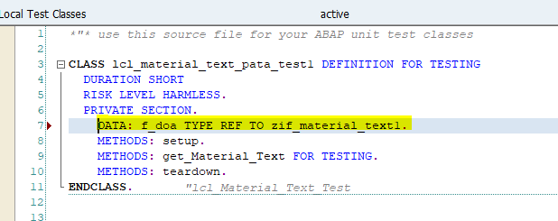

Create test double framework in setup method as below

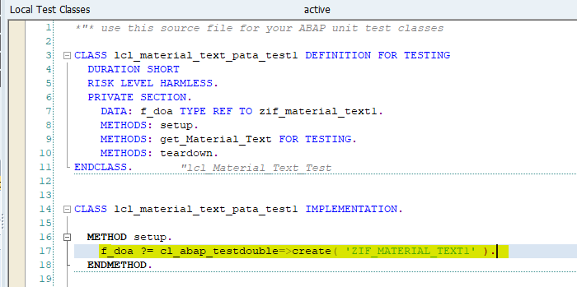

And importing parameter ‘**IM_DOA**’ with reference to the ‘**ZIF_MATERIAL_TEXT1**’ in product class method ‘**Get_material_text**’ as below

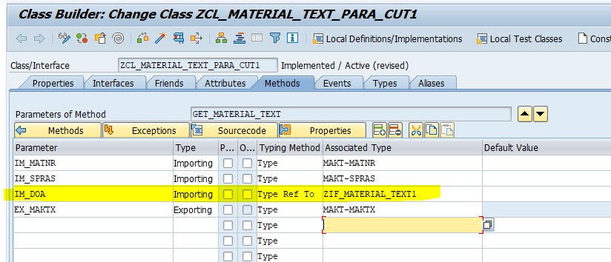

Go to source code of method and changes code as below

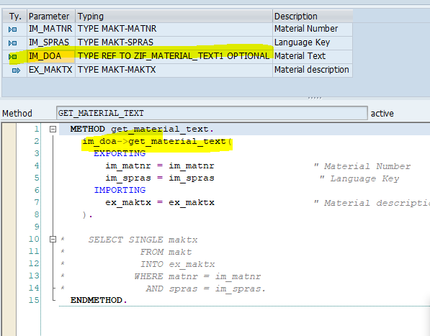

Go to test method ‘**get_material_test**’ of test class

In test method pass test data to exporting parameter ‘**EX_MAKTX**’ using test double parameter as below

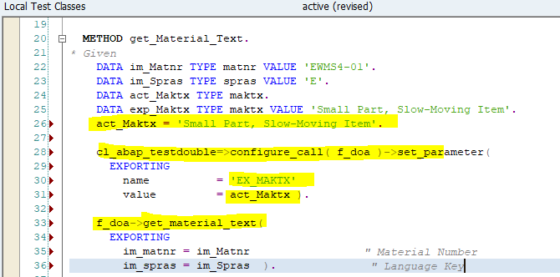

And pass test double object ‘F_DOA’ in exporting parameter of product method on product class in test class method as below

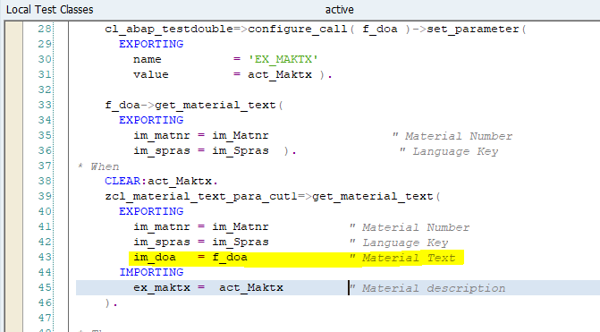

Activate class

Execute unit test

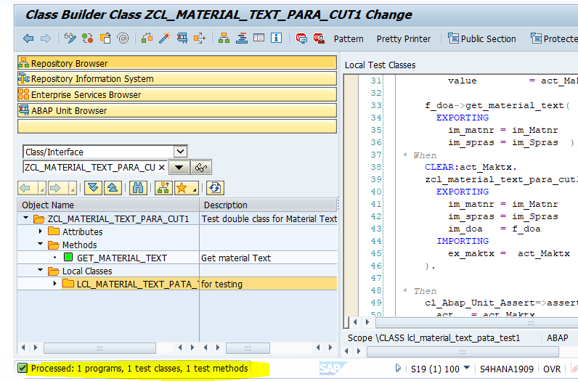

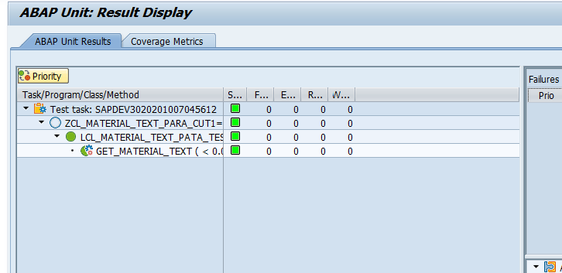

This Test case is passed and it is getting test data from test double framework

#### Backdoor Injection

Create class ‘**ZCL_MATERIAL_TEXT_BACK_CUT1’** in SE24 and add description as below

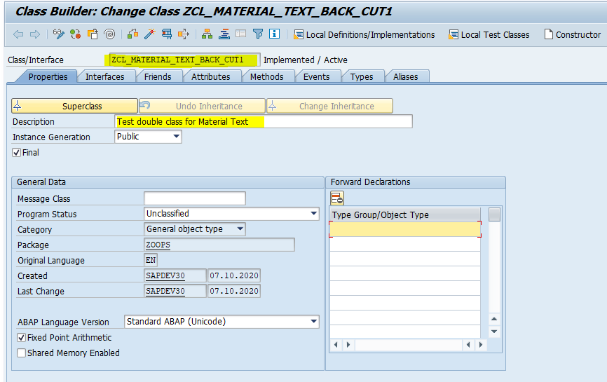

Go to Local test classes button to write local test class

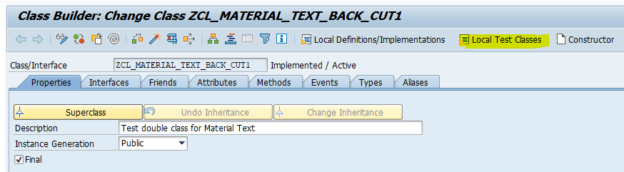

Write local test class ‘**lcl_material_text_back_test1**’ with duration, risk level and fixture method as below

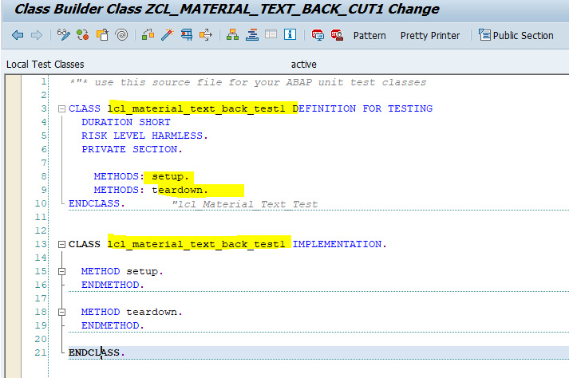

Declare test method ‘**get_Material_Text**’ in class definition and Implement as below

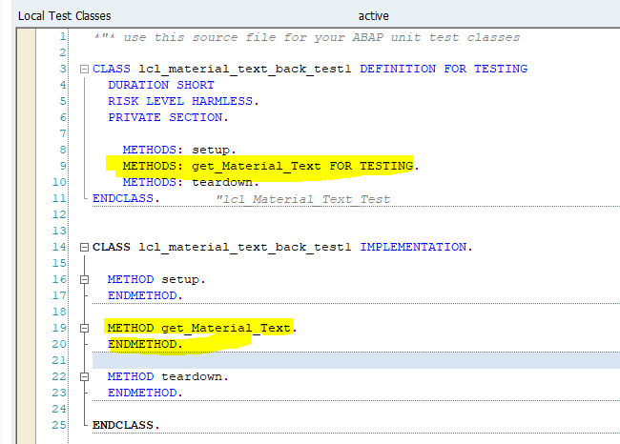

Add Given, When, Then in test method as below

In Given part , We are passing Material no and language with exporting variable ‘**IM_MATNR**’ and ‘**IM_SPRAS**’ and expected material text is ‘**Small Part, Slow-Moving Item**’.

In When part, declaring product method to return actual material text in ‘**ACT_MAKTX**’

In Then part, Comparing actual and expected result by assert method ‘**ASSERT_EQUALS**’

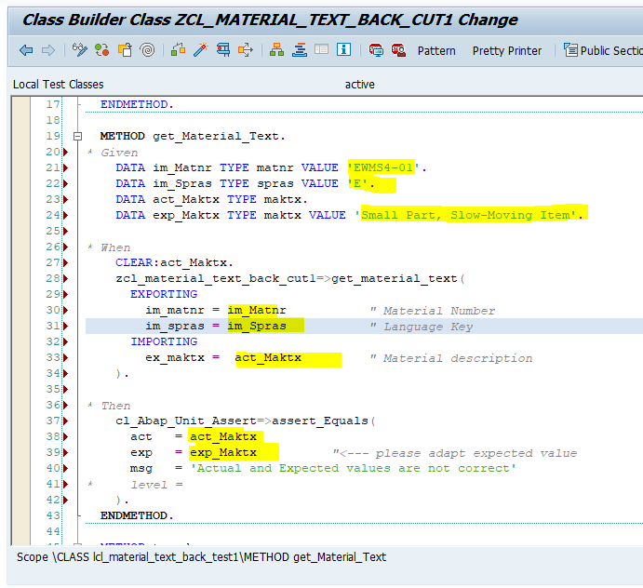

Double click on method ‘**Get_material_text**’ to create in product class then below pop-up will come



Click on Yes button

Enter Description, select public as visibility and static as method

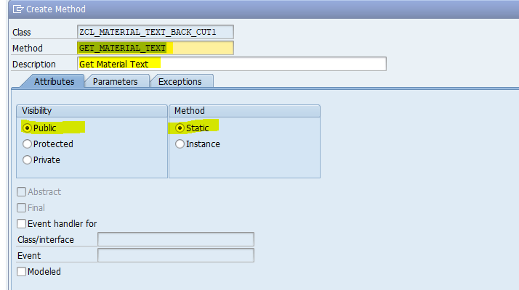

Enter importing and exporting parameter in parameter tab as below

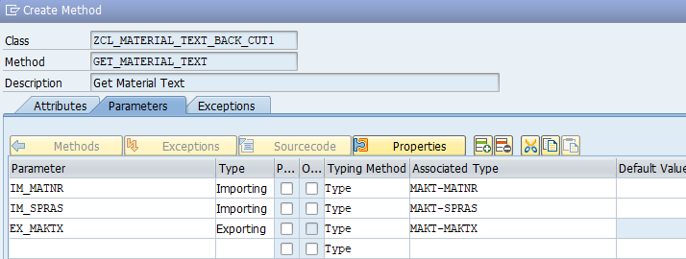

And click on create button.

Now method is created in product class

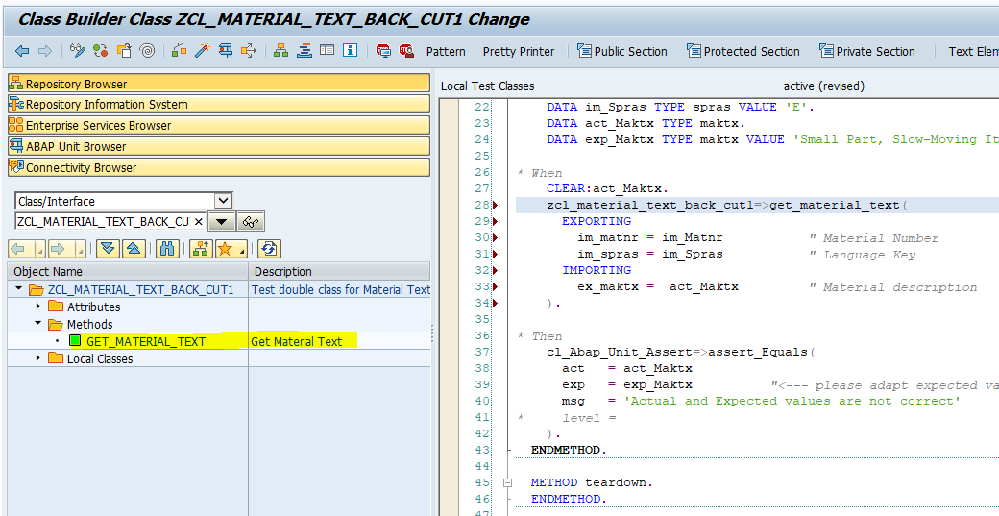

Activate class

Execute Unit test case by shortcut **‘Ctrl+Shift+F10’** or menu path ‘**Local test classes->Execute->Unit Tests**’

Unit test case is fail because no product exists inside the product method

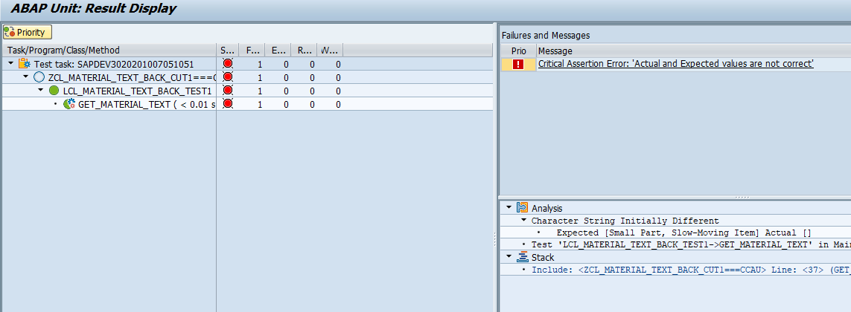

Add product inside product method to pass test case as below



Once again execute unit test

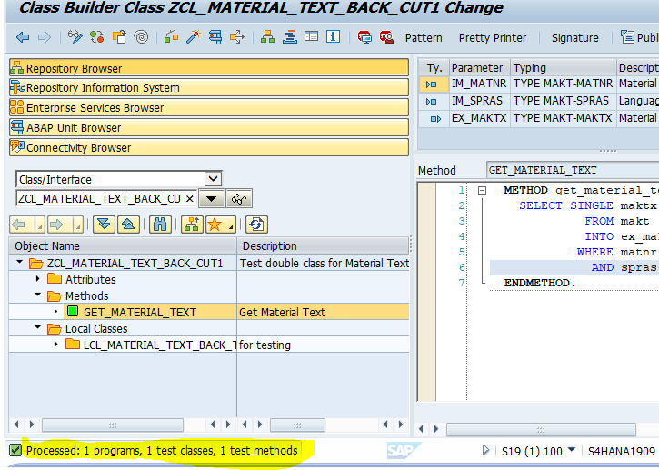

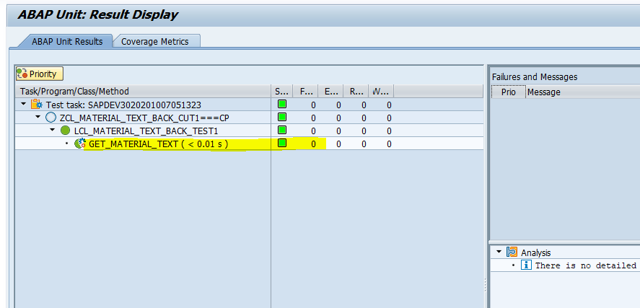

Now test case is passed

Select query is for select material text is depending on the database, If there is some changes going on database layer then we will not able test our unit test



For that, we need to refactor code and use test double framework to break dependency of object

##### Interface & Class

Create Interface ‘**ZIF_MATERIAL_TEXT1**’ to configure test double framework.

Go to SE24 , Enter Interface name ‘**ZIF_MATERIAL_TEXT1**’ and click on create button.



Enter description



Enter method ‘**GET_MATERIAL_TEXT**’



Enter importing and exporting parameter to method as below



Activate Interface

Create class’ **ZCL_MATERIAL_TEXT1**’ for implement Interface ‘**ZIF_MATERIAL_TEXT1**’.

Create class ‘**ZCL_MATERIAL_TEXT1**’ in SE24 and Enter description.



Click on save

Enter Interface name in Interface tab as below



Go to method and double click on it to implements



And select query to get material text



Activate class

Go to class local test class of class ‘**ZCL_MATERIAL_TEXT_BACK_CUT1**’ and declare object ‘**F_DOA’** with reference to ‘**ZIF_MATERIAL_TEXT1**’ in definition as below



Create test double framework in setup method as below



Create global attribute ‘**GD_DOA**’ with reference to the ‘**ZIF_MATERIAL_TEXT1**’ in product class



Add ‘**set_object**’ method in method tab by click on constructor menu button



And importing parameter ‘**IM_DOA**’ with reference to the ‘**ZIF_MATERIAL_TEXT1**’ in constructor as below



Add below logic in constructor



Declare object ‘**F_CUT**’ with reference to ‘**ZCL_MATERIAL_TEXT_SETTER_CUT1 ‘**in test class definition as below



Create object ‘F_CUT’ in setup method and call method ‘**Set_object**’ of product class and pass test double object to exporting parameter ‘IM_DOA’ of method as below



In test method pass test data to exporting parameter ‘**EX_MAKTX**’ using test double parameter as below



Go to product method ‘**Get_material_text’** of product class ‘**ZCL_MATERIAL_TEXT_SETTER_CUT1**’ and change logic to get data from class ‘**ZCL_MATRIAL_TEXT1**’ as below.



Activate class

Execute unit test



This Test case is passed and it is getting test data from test double framework